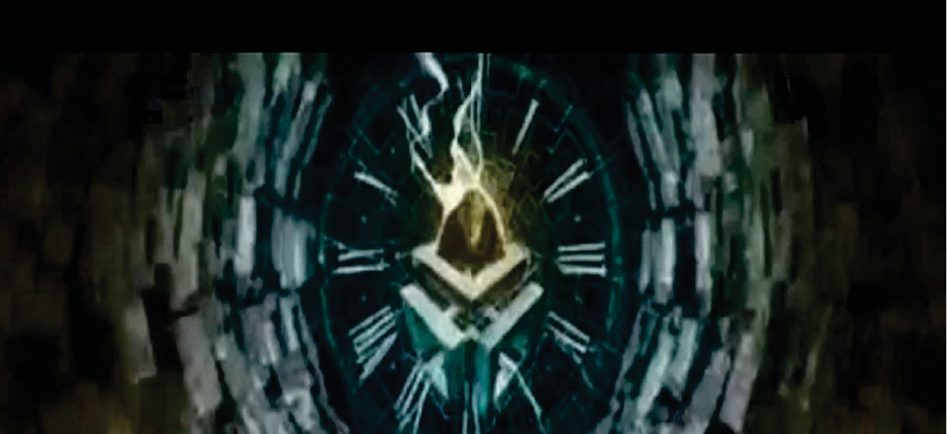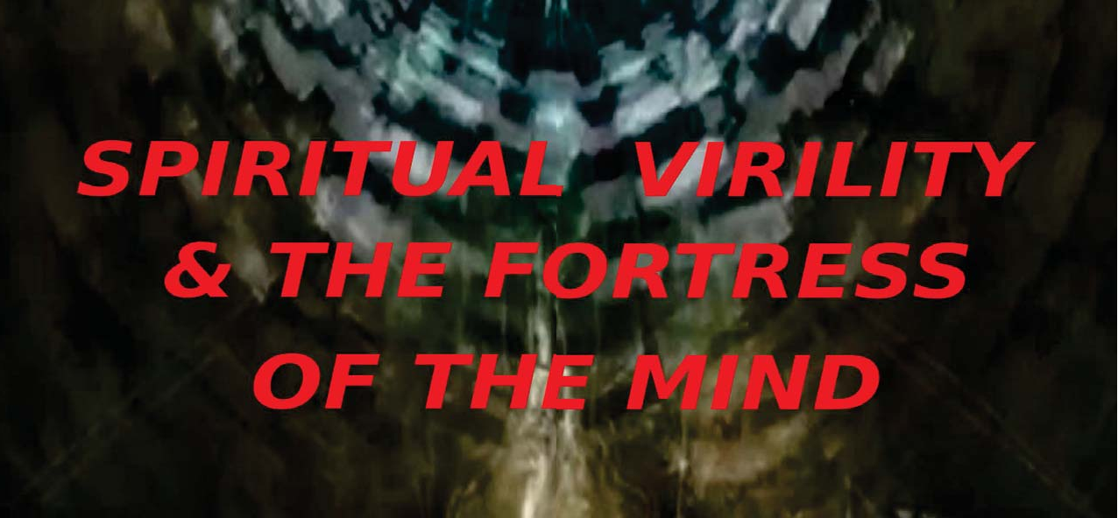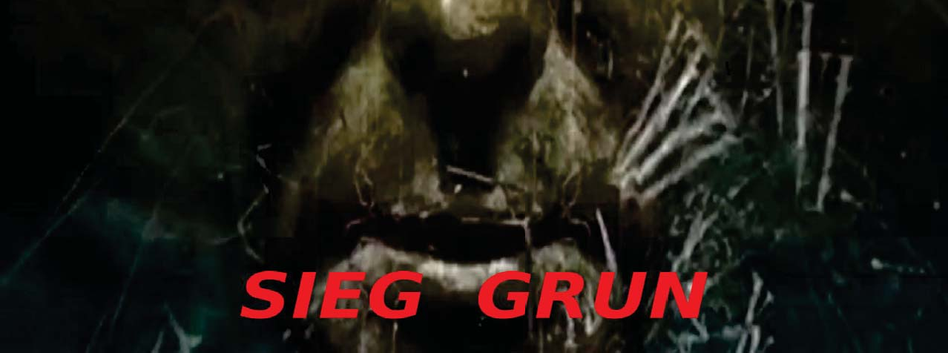

Spiritual Virility and the Fortress of the Mind

The system of the world order may be characterized as a 'gynae-cococracy', in the terms of Julius Evola, or a 'matriarch', however created behind whatever false appearances of paternalism, such as in the presence of Abrahamic priests (all of whom, it must be mentioned, adhere to a feminine consciousness simply by virtue of their priestly maieutic function as pontiff between the divine and the world, the role of a passive medium, not the active or virile form of spirituality of the initiatic priest-king).

The nature of a 'society', by definition is feminine, as is democracy, its contemporary form of collectivism, by definition a 'totalitarian', system owing to its omnipresence encompassing the totality of its membership, all of whom must participate and failing to do so amounting to not only a rejection from 'society', but a destruction of one's being at its hands (the modern phenomenon called 'community policing', or gang stalking being a prime example of this destruction of the 'Other', by the collective as mobilized and directed by its 'genius', the oligarchy of self-appointed judges or 'wise men of Zion').

The matriarchal despotism is thus a 'force to be reckoned with', both in the popular sense of a source of antagonism and threat to the collective and in the technical sense of a 'reckoning', or employment of reason and understanding to deal with it in an effective way 'riding the tigress', of (post)modernity without being consumed thereby, without being phagocytized by 'the beast'.

The panopticism of the Beast with its infinite eyes (the eyes of Jehovah on earth, Jehovah-Malkuth embodied in the form of his chosen people, 'lsrael'), is the Deus Vult, a, 'face of god', one must confront, and this in the form of cameras and endless spies who are not only directed by its 'genius' to target one, but via their A.l apparatus, mobilizing the hive mind swarm consciousness against they who display any aberrant behavior or slightest anomaly. This influence of collectivism is the influence of the mass mind in operation. The mass mind is constructed, as aforesaid, by way of A.l technology maintained by the hidden hands of the cabal, capturing preexistent collective consciousnesses and attempting to merge them together into a 'bulk chaos', or egregore of 'international ethnic mush' (Robert Ley).

Presumably other presences intrude into this preexistent conglomeration of entities, comma, various 'culture organisms', and external presences (egregores), i.e. psychic entities and other 'powers and principalities' of the air (which are attempted to be subordinated to the hierarchy and of which many, if not most, are, as it were, limbs or appendages of that same hierarchy and seek to assimilate within their larger hive mind or purely for themselves as nodes within that hive mind as an energetic food source to 'phagocitize', and swell their own essence with the external energetic source.

This psycho-spiritual overlay or superstructure 'steps down', into 'the world', crystallizing into material forms that have formed through evolutionary processes and within the causal planes of the Demiurge (his substance), and serves to trap within the captive Spirits and other sentient life brought low through this process and trapped within the planes of lower density to be preyed upon by the higher forces.

The consciousness of the cabal is a hive mind structure manifesting itself in the form of an oligarchy and hierarchy, tracing itself to Jehovah-Satan at its highest level. On this basis, it may fairly be said to be a feminine consciousness being as it is a collective with only relative degrees of autonomy merged to these same degrees into the omnipresence of the Demiurge as a spider's web of nodes assimilated into the anima mundi and above this to the Cosmic Mind. The physical specimens on the mundane plane referred to as, 'human', or other they who are assimilated (and this to varying degrees), or those who are unassimilated and still preserve their autonomy of consciousness (and this also to varying degrees), as a sliding scale of assimilation or autonomy at either end of the scale.

The hive mind functions to assimilate those it has not captured by way of 'sympathetic resonance', or the laws of the Demiurgic universe (thermodynamics; the independent Spirit energy sources that are the captive Spirits being sought out for assimilation of necessity by other entities who gravitate toward these same as essential processes of their consciousness to swell their own essence at the expense of external energy sources). Hence it, life, is a battle for survival within this realm, that which is the, 'valplads' (battlefield), that is earth at this and other densities within the realm of the Demiurge and the captive Spirit, thus must of necessity fight against assimilation into the hive mind in order to perpetuate themselves, their life force and avoid the vampiric influence of 'Others', avoid being assimilated into that which is 'Other', to themselves.

The archetype of the collective (at whatever level or dimension), of the hierarchy reflects that of their 'god', Jehovah-Satan, that of a vampire seeking to assimilate the life force of others for itself and to take as much for itself as possible while giving as little of itself as possible. Such is life within the world of social darwinism and this may be the possessive individualistic nature of the hierarchy but it is nonetheless of a feminine nature being oriented around the hierarchy and collective and its contest between relative forces, greater or lesser powers, the lesser being subordinated and typically sacrificed to the greater and all serving (of necessity), the higher and highest powers through their existence being bound up with the collective, failure to serve it amounting to a suicidal act of self destruction as being immediately upon detection turned on by the collective mass and rendered 'nodes of the hive mind', recognizing that their own self-interest is threatened by those who may be an exception to their rigid closed system of entropy, the perpetuation of their lives as lived at lowest density. Those few who can recognize that their self-interest (the interest of their True Self), exceeds the bounds and his 'universe', recognize the value of those who transcend his limitations and hive mind influence and seek to work with him, to whatever degree they are conscious of the necessity of so doing, to achieve a dismantling of the hive mind and their own and other captives liberation from the densification of the Demiurge's substance that forms the lower seven habits.

The system of the hive mind is matriarchal and concludes, conduces to unfreedom, only the illusory freedom to partake of worldly sensuality and become ever more assimilated into the hive mind along the sliding scale of autonomy/assimilation and away from the state of spiritual liberation. Those who acquiesce to the illusory pleasures and comforts of the system court their own destruction and this is almost certainly the intent of the cabal, namely to beguile and capture its captives so that they will cease to struggle against the webs which ring them round and which subtlely drain away their life force.

Jehovah's hive mind is thus omnipresent and pervades the system and its multiple dimensions within His limitations (the lower seven heavens) and is stepped down amongst the endless array of 'the hierarchy', of which he is the principle.

Within this net or spider's webs, the agents of the hierarchy on the earth plane all have their particular roles and limited function and on this basis their powers are serviceable to their masters at higher levels in the hierarchy and have only freedoms limited to whatever the hierarchy prescribes that suit its own ends, those of assimilation within the hive mind with Demiurge and the spiritual enchantment of its captives within the wheel of incarnation. The priestly caste of Abrahamic religion is the pontiff between the occult hierarchy of a negative, of negative E.Ts (reptilians; mantids; greys), and other forces and figures at higher levels than themselves (the great white brotherhood), yet at lower levels than the, the 'Yahweh collective', negative E.Ts.

These priests, though ostensibly serving the masculine principle of spirit are themselves thoroughly feminine in their consciousness. The Abrahamic priest caste is an effeminate group operating on the basis not of Spirit but of soul, of the lower animic principle which constitutes the modality of their consciousness and which they are, they in their arrogance would establish (should the impossible ever become possible), as 'Truth', itself and a means of, to unify with Truth, in reality simply being a mendacious means of unifying with their Demiurge deity who is the lie and manifest and to unify with Him at the level of the soul and sacrifice their Spirits to 'the Lord', as 'the Lord's portion', the portion of their essence they cast aside for the sake of their master, Jehovah-Satan.

Thus, being as they are of a womanly caste, that is to say emotional and irrational, (living in the passions, the 'passion of the christ'). The effeminate priests are the controllers of the world order at the highest level amongst whose ranks may be considered freemasons (priests of the order of Melchizedek; rabbis; imams and catholic priests and protestant pastors and likely the priests of Hinduism and Buddhism, though the writer is not fully certain as regards these latter groups).

The matriarchal despotism of modernity is not in any way 'secular', alone, but it is a worldly despotism governed by priests who adhere to metaphysical principles based upon semitic ideology, the ideology of 'Oneness', of egalitarianism (what may also be called 'catholicity', or 'universalism', according to one of its formulations co-opting the preexistent structure of the Roman Empire and its preservation of difference and its excessively lenient accommodation of difference, enabling the semitic mind virus of equality to leak in as so much sewage, transforming the once relatively pure Roman type into a semitized type).

The co-optation of the 'blood pact', by the 'culture pact', is a historical process which has transformed the once virile and masculine culture oriented towards Spirit and away from the cthonic-tellurian mother-goddess cult and its effeminate priests towards this latter, away from the warrior-monk, or 'kshatriya', where this solar-Olympian praxis and correlative state of consciousness, that of an ascetic detachment from the passions in an inward focus with one's actions based upon a creation and a spiritualized world and a return to Origin. Not so much the matriarchal despotism (either in its form of the semitic priest cult or in that of the more secularized democracies of their kosher socialist variants). These all trend downwards toward the swamp of the lowest common denominator and submerge the higher into the lower, rather than seeking to extricate themselves from that same swamp and to rise under their own power to a higher state of being while assisting others (unlike the self-serving

possessive individualist who lives to serve themselves and themselves alone). Whether the matriarchy be operated on a physical level by actual physical females or by the effeminized priest caste of judeo- masonry/monotheism, it is the cultural superstructure which has an effeminizing influence on the consciousness of the population. This has become the tenor of the mind of the population under modernity's matriarchal system and yet has always been its, 'tenor', throughout history (the history which may properly be called 'modernity', i.e. the Kali Yuga, the Piscean Age and beyond to the Taurean Age of approximately 5,400 years span).

Matriarchy is thus an effeminizing presence that renders all of its 'citizens' (bon homme of modernity), effeminate, their lives oriented around a pansexualism and sensualistic soulishness, the soul (represented by the woman and embodied in the 'mother goddess' figure) coming to preponderate over the spiritual consciousness.

Those of contemporary modernity who the matriarchy favors are those who are least oriented outwards, what Julius Evola called 'spiritual virility', those whose consciousness is either inherently effeminate or oriented toward the passions (and preferentially for the cabal), away from both reason and Spirit. Hence the cultural conditioning and behavior modification the cabal superimposes on its charges as means of rendering them effeminate (encouraging a materialistic mammon-oriented motivation and a hedonistic licentiousness as means of establishing the soul as a preponderating influence over the Spirit), and therefore 'docile bodies', more easily enslaved and controlled by the powers that be. The white man the cabal perceives as its greatest threat owing to his natural inclination towards Spirit born of his Hyperborean blood of his being a distinct, a 'stranger in a strange land', existing within the world and by definition an adversary thereof as a materialized reflection of the adversariality between spirit and matter within the system being of the demiurge and his creation, i.e., a satanic system of materialism whose emphasis and focus of the consciousness is upon the soul, in a state of what Nimrod de Rosario called 'Spiritual reversion', that being an orientation of the Spirit away from the Actual lnfinite, Hyperborea (its origin), toward the 'false infinite', of the Demiurge and His creation (which is himself). This process of 'Spiritual reversion', is that through which the cabal attempts to drag down the consciousness of the spiritually virile (the white man specifically, though other types have and do receive targeting such as Japanese; Arabs and whatever other leader or group embodies and orients themselves toward a spiritually virile state of being, that which is transcendent and above the chaos of the animic principle of consciousness). The animic principle is thus the central point around which the cabal polarizes in its cultural superstructure.

Making of this the quality of its culture of creation-everything (cultural artefacts, music; art, etc.), oriented towards emotion and passion and not an aesthetico-cultural artefact, which leads inwards, away from the false infinite. Hence the culture of the world order is effeminate in being oriented towards a soulish aesthetics and this is the cultural weapon it employs to passively wear away any resistance of its adversaries, bombarding their consciousness with sensa (sights; sound; sense, semicolon, tactile sensations; vibrations, etc.), a multi-sensory assault against the consciousness of the higher in order to tear it down and reduce it to a controllable energy source upon which to feed.

The process of effeminization thus is oriented around what Nimrod de Rosario called 'Spiritual reversion', the making of this 'Spirit sphere', trapped within the world and unresistive receptacle of energy, a de facto battery that may be fed upon by the cabal of vampires, the effeminate priest caste of Zion.

The praxis of priestly power is a praxis inherently corrupt and this owing to its being a cult hidden from the sight of the population so that only they have knowledge of Truth and maintain the population in a state of ignorance, denying them the means to actualize their Self and attain their proper destiny on earth. The inherently corrupt nature of the priest caste (and this by virtue of its being a caste) predestined it to its own destruction as being a crystallized structure wherein only the dogmatists hold absolute sway and others have none or minimal influence over policy and any dictates or fatwas the orthodoxy issues becomes a hegemonic superimposition upon the 'laity', or their 'flock'. Hence the notion of the shepherd king of masonry (the esoteric priest caste ruling under jewry), is by nature corrupt as being structured on the basis of a pyramidal scheme without any flexibility in its ranks and therefore leads to its own inner rot and atrophy and not being sufficiently flexible to adapt to circumstantial changes in its environment and therefore leads to decadence, its "absolute power corrupting absolutely", and this based upon the false premises of its deity, the Demiurge, that 1) such a being is perfect (perfectio dei), and 2) that the particular esoteric religious programs are true or largely true rather than being pure invention of a particular group or groups (extraterrestrials? Jews? Both?), and for a particular time/aeon, and place/psycho-region. Given the corruption, chaos results as the "map doesn't fit the territory", the exoteric religious ideologies not corresponding to the state of affairs of the Time and place (or indeed of any Time and place), and this owing to their being purely invented ideologies. Therefore, the inherent corruption of the priest caste leads to divisive and corrupt behavior, not acting on the basis of Truth, the inevitable consequences are acting divisively and generating more chaos than order, redounding to a state of entropy and ultimate destruction as the entirety of the Kali Yuga. With its predominantly priest caste hegemony has been witness. That priests and exoteric religions are therefore a corruption within the pyramidal scheme of most exoteric religions. lt follows that they will create or maintain nothing but corruption, an unsustainable regime of priestly caste despotism, which is governed on the basis of secrecy and intrigue. The crystallized dogma, by virtue of its existence against the Truth thus provides an environment for intrigue and similar modes of feminine behavior (rumor mongering and power games; the manipulation of the population for the purpose of amusing themselves playing 'human chess', and this too 'maintain', their power over, 'the flock', generating fear and social chaos, e.g. crusades; wars; revolutions, etc.-and this typically through their proxies), such as in the case of jewry, leading the rabble or foreigners to attack the population and then causing them to be put down as a scapegoat for their own intrigue, working in conjunction with both muslims and christians by turns.

Within the segregated enclave of priestly exclusivity yet further forms of corruption of an effeminate nature inevitably result, those being rooted in the suppression of the desire of consciousness as per the mandate of 'ethics', of the religious program, that anything related to sex is 'sin', and therefore must be 'snuffed out'. This of course leads to: 1) an inhibited consciousness and neuroses; 2) on that basis a suppressed state of mind leading to violent outbursts as perverse expressions of that defective and abnormal (unnatural), state of consciousness. Such an aberrant mental state (and indeed state of soul beyond this), is extended into other related forms of behavior for which they are notorious (e.g. pedophilia and sodomy). Given the ancient religions of the Near East and 'Middle East' (e.g. lndia), are simply replicated in Abrahamic religions and others but especially in the former, it follows from the premises that the sodomic rights, (of the back) passage, are integral in the same though not revealed to the masses, nor in the exoteric interpretations of their text. That the priest seek communion with their deity is itself an effeminate act, a merger with 'the One', with the father as a 'submissive' ('islam'- submission), slave to a master by definition, the act of a 'patient', not an 'agent', and therefore effeminate.

That sodomic rites have been practiced throughout history (as is revealed in the article of Bruno Cariou "The Mother Goddess and Her Homosexuals"), especially in the Near East and especially amongst the passages, it follows from the premises that there are reasons why this has been consistently done and is almost certainly done today by such institutions as the catholic church and others. These reasons may relate to causal processes of occult and physical anatomy that opens up or activates chakras and that therefore are conducive to pineal gland activation or something of the sort (triggering certain nerve plexuses and the, 'working up', of the kundalini to the higher chakras). Given this 'process', of these synarchic initiatic rites, it follows from the premises that the consciousness will be rendered effeminate, playing the role of a receiver of such acts (and this presumably from childhood onwards). Such a conditioning of the consciousness (damage to nerve plexuses; burnout of the nervous system, etc.), inevitably cultivates an effeminacy of personality and this, in conjunction with the priestly caste effeminate nature, which is a result of this religious programming (submissiveness; 'humility', and other effeminate traits), manifests itself in all manner of effeminate and devious behavior, which can only be spoken of as those of an idle woman with nothing to do but to seek cheap thrills and entertainment, manipulating and deceiving people and creating outer chaos as a projection of their inner consciousness.

The priest caste of Abrahamic religion, though 'misogynistic', both essentially and in outward appearance, nonetheless, within itself contains the germs of feminism and effeminacy within itself owing to its, by nature, contemplative passivity and irrational quality. Through the influence of such effeminacy (effeminate conditioning), the priest caste radiates its putative 'glory' over its flock and, via the behavioral modeling, of the flock, the latter imitate the behavior of the priest, interiorize in their consciousness the effeminacy of the priest and condition themselves to 'imitate christ' via continual readings of their 'Bible' (buy-bull), rendering them an image of their 'god', i.e. a fictional character constructed by the priest caste and presumably in conjunction with aliens, (the 'Yahweh collective'), of Demiurge-worshipping E.Ts who seek to maintain their slave architecture and loosh harvesting mechanism of the Zion matrix via their earthly emissaries and proxies jewry, and their subordinate minions: masons, monotheists, and atheistic materialists, 'possessive individualists').

Thus the leaders of the flock conditions their slaves to 'imitate christ', and play the role of a passive sheep or shepherd of sheep at a higher level of a cabal (priest of the order of Melchizedek), and thereby these sheep, though ultra-violent in their irrationalism are nonetheless sheep of an effeminate nature dwelling in their consciousness within the realm of the soul as a soulish brute and for that reason subjected to 'effeminate conditioning'.

Though these ultra-violent 'soldiers of christ', claim to uphold 'justice', what they really seek is a working up of desire consciousness, to pursue excitation, to traffic in the coin of desire whose flip sides are respectively: eros and thanatos, the pursuit of pleasure in the form of lust and pleasure in the form of sadistic violence both reducing to their 'pleasure principle', the desire of pleasure, of the desire consciousness ("the comfort of being sad"-Curt Cocaine) or, nonetheless being 'happiness', through a jugular vein (the unification of opposites within the soulish dimension of materialism of the animic principle of the being, i.e. the soul, the 'lunar consciousness', rendering the being a 'lunatic').

Hence the flock are rendered effeminate by the Demiurge priest cult and restricted in their consciousness to the soul. This state of consciousness (perhaps inherent in the semite and related groups?), accommodates the physical female in a position of rulership, if only behind the scenes, with the physical female thereby being in a position to gain power through intrigue and behind the scenes manipulation, working as a collective to rule over the effeminized male with his lunar consciousness, reduced to a sycophant groveling before his female master, wittingly or unwittingly, and usually the latter (being unconscious of the prevailing influence of his female master). That the female, in spite of the hyper-masculine machismo, the displaying of ostensive 'manly prowess' as a 'soldier of christ', prevails over him (his consciousness having been reduced to the level of the lunatic, full of emotion and pathos without any higher principle of consciousness).

Thereby, through this religious programming, the population have their consciousness restructured along the lines of the semite, along the lines of the soul and therefore are subjected to a reactive mental state, reacting to stimuli/phenomena on the basis of emotion rather than integrating into themselves a percept of an, as an element of their being in an active 'Solar-Uranium', mode of consciousness situated in the 'Origin', what may also be called a 'Hyperborean state', that of the super rational intuitive/intellective consciousness, and this as an active process of integration of the external and the internal (cf. Julius Evola's "Magical Idealism").

The current matriarchy which enslaves this world (and this under the robes of, or rather, 'gowns', of the Abrahamic priest caste), is thus enabled to establish itself through the predominance of soul over Spirit, of the hegemony of the lunar consciousness over the solar-uranian Hyperborean consciousness. Therefore, the system and its agents deploys/employs its lunar collective culture to strike against its enemies who might thereby liberate themselves from their slave matrix. Lunar culture is the working up of lunar consciousness on the part of the conspiracy via its cultural artefacts and fetishes, which lead the consciousness to immersion within the mire of emotion, reduce the level of soul and put into a reactive minded state.

This is the 'cunt hook', which seeks to pull the masculine consciousness into itself and to dissolve it in the corrosive waters of emotionality, this lunar cultural conditioning. The culture of modernity is thus based upon the consciousness of the female and its processes; artifacts and objects (commodities; architecture; aesthetics and sound in plastic or graphic form), all derived from the vaginal orifice of the lunar-semitic mentality and not only enable women, the natural and physical embodiment of feminine-lunar consciousness identifiable with the soul itself, to gain power as this receptacle of lust and desire, but to usurp power and work towards the total submerging of the Spirit into the swamp of emotion. ln order to extricate oneself from this swamp of degeneration of the Spirit (in the most literal sense of perpetuating the enchantment of the spirit within the matrix of Demiurge), one must not only oppose a matriarchal despotism, but must affirm and assert a spiritual worldview and way of life over and against the 'current of disintegration', perpetuated by the cabal via their reduction of level of consciousness from Spirit into matter.

The endless rhetoric related to 'peace', is a case illustrative of the distinction between the lunar and solar consciousness with the cabal's notion of 'peace', meaning a superimposition of conditions by way of force upon the external world of the Demiurge and the notion of 'peace', as viewed from an inner perspective sub species aeternitatis, being a state of dwelling within the 'Origin', being removed from the transience of 'the world'.

That effeminacy is pervasive in the modern world is something that anyone with any mind can verify through simple visual observation. That its influence must be combated is a fact that most are unaware of and are unacquainted with and therefore must become so acquainted.

ln the combat against effeminacy, it is first and foremost an inner matter, a question of a conquest of the inner being that is oneself, exerting self-control over his lunar principle of consciousness, or rather divorcing himself from the lower principle of consciousness, that is to say the soul, the lunar consciousness being eclipsed by the solar-uranium consciousness. ln pragmatic terms, this means shunning and avoiding, if the self is not sufficiently strong, the lunar culture of the synarchy. This synarchic culture may serve as a stimulus to challenge the Self and to situate it in the self as a reactive or autarchic counter-action to the action or phenomenal effect brought against them by the external forces 'impingement' upon their consciousness.

Those not so developed (and indeed even those superlatively developed), should the stimulus not be conducive to the strengthening of the self in the Origin, not assisting in its maintaining its gaze directed inwards toward the Actual lnfinite, being antithetical to its self-centeredness (end), must therefore shun and avoid the external as means of maintaining their place in the Origin or working in this direction should they be in a condition of 'Spiritual reversion', with their consciousness directed toward the false infinite, false infinity of the phenomenal world of the Demiurge and focused through the lunar principle of their body-soul-Spirit complex).

The hypernormal stimuli of the 'with world', of the synarchy, the artificial world which seeks to engage in its kaleidoscopic world of sense (sights; sounds; smells; tangible impressions; the various fascinating images and objects of artificial invention-song; hymns; icons; flavors; sense; salacious images, etc.).

He must live as an ascetic in relation to these phenomena, avoiding and not possible to avoid, ignoring them and their magnetic influence which seeks to pull him into their ambit and to phagocytize his consciousness becoming objects of obsession conditioning his consciousness towards 'Spiritual reversion' and a draining of its vitality into the phenomenal object. And this through what in scientistic terms is called 'quantum entanglement'.

Thus an ascetic avoidance of the culture of the 'synarchy' is indicated save in cases of providing a challenge to the person/self in overcoming the influence of the external phenomenon or century percept. A life lived as a parallel life 'in the world, and against the world', viewing the world with, if not indifference, then hostility, as was the assertion of Nimrod de Rosario regarding the stance adopted by the awakened virya, to view the world as a 'valplads', in ancient Norse or 'the battlefield', upon which to give combat against all entities. This does not mean, however, an emotional reaction to the stimuli, but a recognition of their constituting and antagonistic force brought against the Being/Self and thus something which must be neutralized through effective resistance, assimilated into oneself rather than to allow it to assimilate the Self into itself (psychic phagocytization through having the object become a focal point or obsessive focus and to transmit to it one's conscious energy, draining his life force in projecting upon it his gaze (inner and/or outer).

Thus an avoidance of uncontrollable hypernormal stimuli (and within modernity even, 'normal', which is the traditional world, in a traditional world would be considered abnormal, a stressor disruptive of the harmonious condition of their culture organism if, 'universalizable', as a Kantian imperative), is a necessity and this would be the first phase of reversing the process of 'Spiritual reversion', a return to Origin.

Within this 'phase of avoidance', if such it may be called, a quietistic life must be led with an emphasis on meditation and silencing of the mind within the context of a 'pure life' (a vegetarian diet and a relocation or situating of oneself in a quiet environment with minimal external stimuli) for the purpose of reorienting the focus of the mind on the inner and establishing itself in its proper place, severing ties to the mayavic planes of the Demiurgic universe.

Once a sufficiently strong foundation for the fortress of the mind has been established, he may then subject himself to challenges as well as the development of psychic powers through which his gaze is no longer in a state of patiency but rather in that of agency, of an active and autarkic (self-governed), stance through which he may contend with the external 'valplads', and give combat to the entities which seek the fatalisation of their consciousness.

lnner weakness is the mainspring of all degeneracy of the person and by extension the cultural organism with which he is bound, the inner weakness of the leadership radiating outwards amongst the populace and influencing them to follow their own path towards destruction and not only mimicking their leadership but through having a lack of compass along which to tread, following the path of the abyss into destruction.

To positively influence one's kind one must abide by his principles and these being suitable and most appropriate for the elevation of both himself and his kind (his 'culture organism', as Spengler and Yockey have referred to the racial soul).

One must lead from the front. lnner weakness must be viewed as a Trojan horse of the enemy (the animic self, the influence of the Demiurge), and this in its myriad guises. The qualities of the 'man of race', he who embodies within himself the Hyperborean blood, the graal, the litr godi, and who exists authentically according to his essence, are defining of who he is as a 'true man', or, 'man of heaven'.

The quality of reserve, of a detachment from the 'with world', and its chaos of sensory bombardment, is one of the fundamental elements of the essence of the transcendent man who in controlling his emotional reactivity and restricting any animic impulses in relation to 'externals', as depicted as called them. To cultivate restraint, one must cultivate the mind and build his 'fortress of the mind', his inner archemon (one rule), becoming an 'autark' (self-ruled), being whose relationship to externals is one of 'autarky' (self-ruled), self-governed dominance of his base drives and any animic propensity towards reaction, yet in a state through which action may manifest from the higher principle of will.

This last comment brings us to the next something, trait of the autark who embodies the 'spiritual virility', that is sought in the combat against effeminacy and moreover sought as an in itself as means of returning to Hyperborea, to the Origin and being situated within the Olympian nucleus of his being, the essential conditions of preserving his essence as a spirit sphere, a 'vimana', over and against the 'current of disintegration'.

This is the trait of the training; development and exercise of the will upon which subject the work "Finding Shelter under the Swastika-Exercising the Will", by Hager is a useful work along with the work of Julius Evola "Magical Idealism", wherein the techniques are discussed through which the will may be directed over and against the brambles of phenomenal appearances and states of consciousness bound up therewith. The work of Jose Aragon "The Forbidden Parapsychology", also amplifies in explicit detail most useful techniques of mental influence and magical techniques to empower the self and direct the will against others via psychic attack. The organization 'Joy of Satan Ministries', also has some valuable techniques which can be employed as embodied in their "Hell’s Army, Spiritual Warfare Manual", [the cartoonish terminology and references to 'Satan', can be overlooked and discarded as a True Satan is Jehovah and the world(s), of His creation over the true hells of existence].

Spiritual virility thus entails the detachment of the self from the world and from the animic principle of the phenomenal self and the cultivation of will, its direction and control in relation to 'externals' as a potent weapon of war brought against the foe. The ascetic life of consciousness and detachment from the external and internal world of turmoil and living as minimalistically as possible (voluntary poverty), maintaining whatever outward appearance of social acceptability necessary to attain higher purposes is necessary. The poor man's room of the Stoics must be made the inner sanctum which one occupies at all times and the 'fortress of the mind', enabling him to, 'bracket off', any external impingements that would potentially phagocitize his consciousness through his diverting his will (his 'one-pointed concentration of attention' thereon).

His attention must be directed toward the origin at all times, comma, that is to say being a self- reflective gaze directed towards the Self and away from the phenomenal self of the body-soul complex.

Existing in the Olympian heights with the gods, he exists apart from the fray and musters his forces for war against the enemy within the valplads and the enemy which is his lower self. For this reason he will minimize any immersion in the corrosive waters of the soul to avoid the erosion of the Spirit and the possibility of 'Spiritual reversion', from the True lnfinite of the Self to the false infinite of the Demiurge/demiurgic universe.

Anything soulish and emotional must be restrained and controlled, not shunned and avoided, but incorporated within himself as a vampire, absorbing into himself the external phenomenal appearance, becoming phagocitized by his Will rather than being phagocitized by the will of the external being whose entry into the fortress of the mind enables the potential sabotage of his inner forces and therefore must be, should it be allowed into his consciousness, ab initio, immediately restrained and controlled and if need be placed under constant surveillance or lock and key or even subject to execution (annihilation of the phenomenal percept by ignorance-shutting it out of the fortress of the mind-or through a proper attentional focus thereon behind the appearance via noological/transcendental apperception, seeing the phenomenon as it is in itself beyond the archetypal and at an ontological level of Being, the thing in itself perceived beyond the veil).

Developing the Self he may then go beyond the self and radiate outwards his magnetic influence, which he projects outside of himself towards others such examples of charismatic leaders as Hitler; Stalin; Mussolini; Saddam Hussein, and myriad other figures embody this Führerprinzip or leadership principle which serves as a means through which the population are elevated, rallying around a central figure, the pole around which the surrounding satellites are arrayed and which are augmented in their power through the radiation of power from the central sun around which they are polarized. This charismatic influence may only be manifested through the spiritually superior 'man of heaven', the arhat or adept wise warrior who makes of himself an exception exemplar of behavior and conduct. Dignified; stoical; benevolent, yet within the Nicomachean template of an Aristotle (neither in excess nor deficiency, neither stingy nor overly magnanimous); unyielding in his will (as a name conferred upon Stalin, 'steel man')-the constellation of traits suited to the aristocrat of the soul, he who may then lead the population if not as a political figure then in whatever capacity is appropriate for himself and which he must of necessity carry out as a duty to his own kind and ultimately as a duty to himself to fulfill his purposes on earth namely the spiritual liberation of the population and the annihilation of the warders of the judeo-christian prison architecture.

