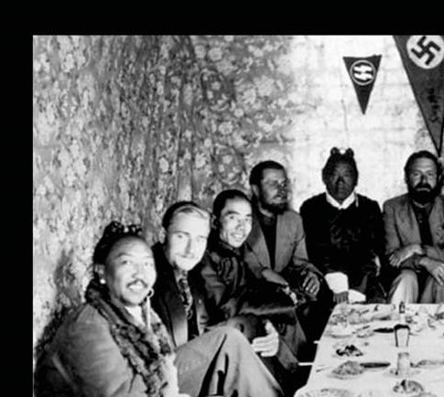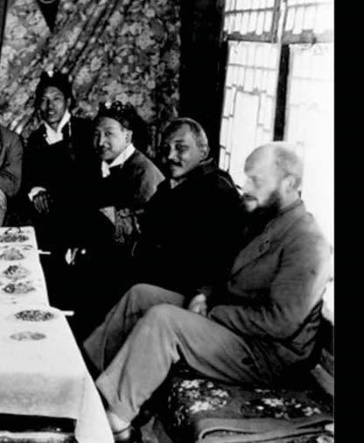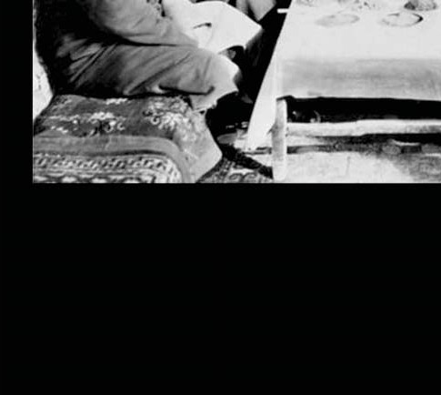

Oriental Allies?

Some figures in the nationalist sphere have considered the notion of allying themselves with Far East Asians as means of somehow securing the survival of the culture and biological race of European man (and in some cases, homo americanus; the North-South American-Europoid). The writer would welcome such an alliance should it be an actual reality rather than a theoretical pipe dream woven out of the vain imaginings of theoretical web spinners and perhaps it is an actual possibility. This he cannot definitively say not having any insider knowledge or intimate acquaintance with orientals or geopolitics and thus can only offer some basic insight based upon the realities of life, which he is adequately acquainted with to serve as the basis of presenting defeasible conclusions.

That all seek the preservation of their own kind and their own expansion and empowerment as a collective when in a sound state of mind, recognizing that the empowerment and vitality of oneself is intertwined with the empowerment and vitality of the collective of which he is a part, he must need seek the state of being of both himself and his collective as no separation between self-advancement and collective advancement is conceivable save in a world of abstractions and true 'vain imaginings'.

Therefore of necessity, should the racial collective and himself as a member thereof survive, it will do so in a state of relative antagonism or conflict with that of others. Therefore alliances can be made owing to the historical contingencies of the moment, but alliances not being covalent bonds, are meant to be broken and therefore the pragmatic politician (such as Adolf Hitler), will make alliances understanding their tentative fragility and near certain fragmentation once the winds of time change direction.

The writer would welcome any allies who don't harbor any murderous hatred of the Aryan and to unite with them even if only in a separation against the foe, the globalist cabal amongst whose members are many of European stock. However he will acknowledge that this utopian dream is probably not likely to fructify in most cases given that most parties not white view the white race as either crazy (which to a great extent it has become under the influence of jewish mind poison), or a violent warmonger, bent on global despotism, which especially in the case of the christians must be acknowledged as true given their 'christ supremacism', which entails all "bowing their head and bending their knee", to the fictional rabbi Yeshua.

To remove the cause of despotism is to remove the effect, that is to say of despotism itself, and given that the judeo-christians are the 'soldiers of christ', who seek to enslave the earth in the name of their religious philosophy/dogma, and as history has revealed are implicable in their, 'crusading', being the cause of well over a hundred million deaths at the very least throughout their history. Therefore the judeo-christian religion must be neutralized as a foremost obstacle in the path of any sustainable world, given that it is the strongest power block on earth and has its tentacles intertwined in all nations and cultures who are subject to its influence and may therefore be properly spoken of as 'catholic' or 'universal', in scope amidst the 'gentiles', for whom it was formulated at the Council of Nicaea.

For this reason and that specifically its essential praxis entails genocide by a promiscuous miscegenation with all and sundry as South America serves as witness with its mestizos and zambos, etc., hence the juggernaut of genocide and intolerant bigotry must be put a stop to and this necessitates the entirety of the forces of 'humanity', forming a coalition against this power block.

Many such as Franco Freda; Francis Parker Yockey and Jean Thiriart, etc., have formulated similar ideas and plans as the original spokesman of such ideas which may well have derived from Hitler at some point, some basic level as his alliance with Japan; Thailand; Tibet; India, and other oriental as well as Arab nations have bore witness to. Thiriart's work "Europe: A Nation of 400 Million", amplified upon the earlier work of Yockey "The Enemy of Europe", stipulating that America was the enemy of a unified European imperium and that it was necessary for the formation of alliances with foreign groups to wrest control of power (autarchy), and Europe from the 'Thallasocratic' (or 'sea power', the Anglo- American-Israeli axis and all of its various permutations and projections which comprise its network of power properly called 'plutocracy' and yet still implicitly monotheistic theocracy under the rabbis and priests).

Hence the "enemy of my enemy is my friend", if only until the 'greater'(?), enemy is neutralized as a threat. For this reason, alliances are needed and all who are made to suffer by the
judeo-christian/masonic/marxist, i.e. from J.O.G (jewish occupation government-or shadow government) must be aligned against it for mutual survival. Hence the above theorists almost certainly have the right conception of establishing an international network oriented around an anti- American(ist), anti-globalist purpose, which amounts to an anti-jewish supremacist purpose given that this tribe is the wire puller who lords over others behind the scenes and to their greater parasitical enrichment.

The work of Julius Evola "Ride the Tiger", entails within itself a theoretical recipe that was put into practice by Giorgio (Franco) Freda in Italy during the 60s and 70s and thus may give, along with the works of Nimrod de Rosario, insight into the means through which victory may be had, at least as a preparatory mindset.

The Maoist revolutionary; the kamikaze pilot; the Berserker; the Viking; the knight; the guerrilla fighter-this figure, that of what Nimrod de Rosario referred to as a virya ('warrior', in Sanskrit terms, or Berserker in those of the Norse) such is the path to tread, and one may do this only in an authentic way, not as part of the J.O.G's meat grinder war machine, as its vetting processes necessitate a thorough screening of all applicants and any adversaries who would be spotted, are recorded immediately, and are subject to their covert fourth-generational warfare 'zersetzung' ('disintegration', methodology called 'sikul memukad', in Hebrew, and the main tactical modality of the J.O.G, in clandestine dispatching of its enemies). The question remains: who are these allies? The answer: whatever is pragmatically useful to neutralize a threat as an instrument of that same's removal.

Though one would wish for allies amongst the aforementioned groups, it is perhaps a utopian 'vain imagining', that these same are in fact allies. The following is the writer's speculation on the subject, touching upon the various subtypes of 'humanity'. With respect to the Far East Asians, the various subtypes of this group are diverse and conflictual amongst themselves, as world history has divulged.

The 'Asiatic hordes', of the steppes, such as those who dwell in the Turanian region and further east in Mongolia, have had an adversarial relationship to the Aryan race, having become in archaic times interbred with them, perhaps in some cases, though overcoming their colonies and genociding the population (Samarkand), or mixing in a relatively harmonious manner therewith (Lhasa, Tibet).
Genghis Khan is one such example and Attila the Hun another.

These groups, Nimrod de Rosario has discussed in his work "The Mystery of the Hyperborean Wisdom", and "Fundamentals of Hyperborean Wisdom", as a driving force that has mobilized the Aryans to move against the Kali Yuga's forces working westward (this in his chapter 13 of "Fundamentals of the Hyperborean Wisdom"), as means of facilitating the transmutation of the earth via the lithic wisdom's installation in sacred sites and ley lines.

Thus, the relationship has been one of an adversarial nature between the 'Asiatic hordes', of the steppes and the Aryan, and yet has borne fruit on a cosmic level of being in perpetuating the transmutation of the earth and the liberation of the Spirit from the material plane and the spiritual enchantment of the Demiurge. Rosario speaks of Hitler's patterns of movement in a leftwards? direction against the forces of the synarchy and hence reveals a relationship between the group of 'orientals', and the Aryan race as a tension of development for the liberation of the Spirit.

The Tibetans guard the gate to Agartha and its Venusian realm, presumably in conjunction with the reptilians (nagas) who had departed to the subterranean realm during the persecutions of archaic history (possibly at the hands of jewry and their 'Yahweh collective' or traitor siddhas, the extraterrestrials, those loyal to the Demiurge,).

Ulaanbaatar, as well as in Lake Baikal, Siberia, are also stipulated to be the loci of stargates, presumably contested by the rival faction of siddhas and (probably?), under the control of the loyal siddhas, those loyal to Agartha and the Hyperborean realm.

Similarly, in the Middle East, many stargates exist, which it is fair to presume are largely under the control of the synarchy and which had been under the control of the arabs prior to the invasion by the law, the creation by the 'Yahweh collective' of islam with their, the constructed ideology being invented as means of detaching the ethnic population from their ancestral roots. The arabs, it must be said, are involved in a schizoidal relationship with jewry and this, based upon genetico-spiritual cross- pollination, their religion, especially, being intertwined with jewry, being a program of veneration of the Demiurge. And yet the arabs have hostility towards Zionism, which many of them (if not most?), mistakenly interpret as originated by Aryans (e.g. the myth of Hitler being a Rothschild and Zionist, etc.). On this basis and that of their fanatical monotheistic religion of Demiurge worship (itself being a positive instrument in opposition to the globalists though a dangerous ally and therefore an ally best kept at arm's length and with no formal or official connection thereto), muslims and arabs (nearly all of whom are muslim, else christian, the original religion of treason formulated by the 'Yahweh collective', and jewry) can only be 'trusted' at arm's length.

In the further east, the orientals comprise diverse groups whose relation with the Aryans has been largely positive historically through such as the chinese had been subjected to the aggressive force of Genghis Khan, leading to a degradation of their decadent society (itself 'prophetic' or karmic?), and therefore the relationship between Chinese and Aryans has always been of a schizoidal nature. The opium wars orchestrated by jewry who controlled the British Empire (the Sassoons of original Iraqi jewish extraction and Benjamin Israeli), had been yet another means of antagonism against the Chinese and this presumably to soften up their traditional caste system of the Mandarins as a means of later supplanting this hierarchy and power block with a kosher controlled puppet regime under Mao Zedong and subsequent inheritors of the torch of the communists in that region (now perhaps and perhaps at all times partially transmuted into an ethnic - communist block resistance to outside pressure). China thus has had a relationship of a schizoidal nature with Aryans and with jews as the work "The History of the Jews in China", by S. M. Perlmann reveals the jews having been a presence in the region for at least two millennia (whether they were and are tolerated or no is uncertain in the writer's opinion.

The work "Chinese Perspectives of the 'Jews' and Judaism: A History of the You Tai", Zhou Xun, suggests they may have been viewed with the justified criticism that jews to this day called 'anti- semitism'). Today it would appear China is a pawn in the game of jewry, though Nimrod de Rosario speaks of this schizophrenic relationship in "The Mystery of the Hyperborean Wisdom", with respect to the Third Reich's alleged affiliation with 'the green gang', a secretive organization and their gang's opposition to the sepoy, Chiang Kai-shek, the freemason internationalist and servant of the Anglo- American powers.

Mao Zedong was as far as the writer has discovered a half-breed product of a Rothschild and an ethnic Chinese woman brought to power by the cabal of jews as their 'skolnick' instrument of devastation of the former order of the land of the dragon. It appears as if China has become a pawn of jewry and the internationalist, but this is likely only an appearance as the traditional dragon culture and the presumed presence in the surrounding regions of the loyal siddhas may promise a positive relationship to the Aran, though not the Anglo-Americans. Like all ethnic groups, Chinese serve themselves and their hyper-focus on commercialism mirrors that of jewry and may be either a function of the jewish influence or suggest a common bond with jewry (and perhaps beyond as lunar beings: proto-grey alien hybrids?).

Given that the Chinese have been discovered, (, should one credit mainstream media propaganda), to be involved in the mass vaccination protocol with jewry, it suggests that they are at this present time an enemy of the Aryan. A document was discovered by the writer revealing (assuming it is authentic), a Chinese general lecturing his students about how they would use vaccines to destroy the North American white population as means of expanding their Lebensraum, and given that jewry have developed the vaccine, (i.e. bioweapon), it follows from the premises they are in league together with jewry, certainly intending to shift their base of operations to China and the surrounding regions, as well as South America, once they can realize their plans of genociding white people (if this is possible for them).

Hence the Chinese would appear to be an enemy, though perhaps only an enemy of America and the British Empire, and not of Europe itself and the Aryan race as a whole (doubtful). The writer would be inclined to assume they are indeed an enemy, however, given that he has witnessed them firsthand involved with jewry, both in their 'fourth generational warfare/gang stalking', and being given favoritism by jewry for hiring and other privileges.

With respect to other orientals in the region, some such as Rosario and Miguel Serrano have claimed that the Japanese betrayed the Aryan race by refusing to oppose the expansion of the Russians/Bolsheviks into China, but simply standing down rather than continuing their loyalty to the Uncreated Light and to the National Socialists, offering up a portion of their own population in Hiroshima and Nagasaki as a sacrifice to expiate their 'sins', for affiliating themselves with Hitler and becoming, after the Second World War, a commercial instrument of jewry, having betrayed the Virgin of Agartha, the Spirit. The writer can perceive this to a degree in the Japanese obsession with commerce, and yet he perceives the survival of the samurai nature behind the commercial facade still extent and a presence in both Shinto and Zen and the so-called 'anti-Semitic' motifs in some of Japanese culture. Therefore, he would contend that Japanese can be considered a more trustworthy ally than Chinese and arabs.

The Koreans also, though speaking a language of communism as with the other groups, are nationalistically oriented and have regard for their own kind and culture, and for that reason may be properly considered an adversary of the globalists with their genocidal agenda of miscegenation protocol. Therefore, it may be the case that they are a legitimate opponent to the slavers of the world.

The other Asian countries such as Thailand; Vietnam; Cambodia, and Myanmar may also be considered potential allies given their superior culture and its orientation away from the judeo-christian mind- control system and its religious bigotry.

These same are largely either Theravada Buddhists and/or ethno-'paga' polytheists or atheists, and are thus possible to deal with, though the writer cautions any in dealings with all, especially in dealings with whites, as most all have been conscripted by the dark forces and constitute yet more nodes in the spider's web of the Demiurge and his 'eyes', forever spying and gathering intel on those the synarchy seek to torture and abuse for their personal benefit (ritual murder to their deity Jehovah-Satan, and their 'remote neural monitoring and manipulation' protocol for human experimentation and the enslavement of the world).

The historical relationship existent between the Third Reich and Thailand under Phibun is a more recent instance of the bond extent between Aryan and this Southeast Asian combination, which may have had its origin in the spread of Buddhism from the Indian subcontinent (and this for better or worse), this Southeast Asian group being probably a hybrid product of Zeta Reticuli hybridization with Lemurian stock and Aryan admixture, such as in the case of the Japanese being mixed with the Ainu people, an earlier Aryan hybrid of archaic and tenebrous origin.

In terms of the Amerindian themselves, partially asiatic in origin and hybridized with Aryans, these same have a historical relationship in diverse places and times with both Aryans (specifically Vikings), and much later Spanish; French, and British.

The jewish infiltration culminated in places such as Bolivia and Mexico in the Aztec mass ritual practices and which was a result of perhaps Phoenician migration to the region. Those interbred with jewry are thus untrustworthy and their physiognomy and behavior should give the key to understand how to differentiate the two groups, those hybrid jews and those hybrid Aryans, and to what degree. However, it is not biological race that is the exclusive determinant or ultimate cause of their treason or loyalty toward the gods and their descendants, rather simply a probabilistic factor.

The historical relationship between Aryans; jews, and the stocks of South America have been amplified in the works of Jacques de Mahieu; Arthur Posnansky; Nimrod de Rosario, and Miguel Serrano, and need not be discussed here.

It is only important to understand that jewry seeks to carve out yet another parasite enclave in the Patagonia region and to use their slaves, the christians (especially the catholics-the Americas being a catholic power center, perhaps established as such deliberately from the beginning of the conquistador invasion under the 'aegis', of Cristobal Colón, the jewish rabbi, conscripted by the synarchy for this purpose, which is discussed in Nimrod de Rosario's book "Secret History of the Thule-Gesellschaft")., to paragraph. In conclusion, the asiatics (all variations on the theme), will play a role in destabilizing and ultimately overthrowing the regime of judeo-christianity and the illuminist cabal controlled by jewry, the question remains whether there will be a place for the Aryan, whether any alliances of a sustainable and harmonious nature will be formed and what the fruitage thereof will be.

The writer suggests at the very least a 'hands-off', policy in one's conduct with Asians, not falling to the judeo-christian propaganda trap of vilifying and slandering potential allies and alienating them from the inevitable final confrontation of Ragnarok, and, if deemed prudent on a personal level to facilitate the mutual antagonism toward the system of all parties are involved in the counter-strike. This, of course, does not necessarily mean physical aggression or combat, but simply opposition that is prudent and effective and by whatever means.

