THIRTEENTH TOME: COMPLEMENTARY CONCEPTS OF HY- PERBOREAN WISDOM
The elementary notions of Esoteric Chorology that we have pre- viously developed will enable us to interpret, from the point of view of the Hyperborean Wisdom, numerous facts that until now, except in the closed circles of the Thulegesellschafi, had been the object of synarchic cultural disinformation. We will give some ex- amples of such an interpretation in the following commentaries:

- Hyperborea and the Hyperboreans

In synarchic occultism, a nonsensical and tendentious associa- tion is usually established between the Swastika, the polar or circu- lar movement of the constellation of Ursa Major, the number sev- en, the regions of Turan or Mongolia, and the “Hyperboreans.” As a product of this, aArmations such as this one are “proved” or sub- stantiated: “Mongolia is a center of the Swastika’s diffusion; from there it radiated to all the world”; or this other one: “the Swastika symbolizes the helical movement of the Ursa around the polar star.” We will waste no time in refuting these and many other simi- lar aArmations; in the light of Hyperborean Wisdom and with the help of Esoteric Chorology, we will go directly to the origin of the confusion.
First of all, we must repeat that the Swastika is an exoteric ex- pression of the Sign of the Origin and, as such, does not include a “center of diﬀusion,” since every Virya, anywhere in the world, sooner or later encounters this Sign when, in his Return-to-the- Origin Strategy, he enters into a charismatic relationship with the Gral. This is what has occurred in historical times with peoples who, inhabiting megalithic areas, have ended up “discovering,” by themselves, and adopting as their coat of arms, the very ancient sign of the Swastika.
We are now going to establish a very important distinction about the origin of the “Hyperboreans” because there are at least three traditions worthy of consideration, but contradictory among themselves. We will mention them in order of antiquity and clarify what class of “Hyperboreans” each one refers to, but first we will say a few words about the term “Hyperborean.”
The usual acceptance is that “Hyperborea,” as it appears in Homer and other Greek poets, alludes to a land “beyond” (hyper) where the North Wind (Boreas) blows. But this is a late etymology, from the epoch in which nascent Greek rationalism was associat- ing with each “force of nature” a God or Myth; so it was with the Sun (Helios), the Moon (Selene), Venus, Saturn, the Sea (Poseidon), etc., and, naturally, the Winds: that of the North, Boreas; that of the
1021

South, Noto; that of the East, Euro; and that of the West, Zephyr. Before these mythological reductions “boreas” meant “breath of the North,” as in bóreios (βόρειος) with a dual meaning of “wind” and “spirit,” as is the case with pneuma (πνεῦμα) which has the follow- ing meanings: breath, wind, exhalation, respiration, life, soul, spirit, angel, demon, divine breath, Holy Spirit, etc. “Hyperborean” can be translated, then, in an archaic sense, as a “Spirit that comes from beyond the North” and Hyperborea becomes “the land (or the ori- gin, provenance) of the Spirits from beyond the North.” This defini- tion, evidently inspired by the Blood Memory, is quite in line with the teachings of the Hyperborean Wisdom which aArms that the captive Spirits come from Hyperborea, an extraterrestrial, but also “extra-universal” and perhaps anti-material “racial center.” From there the Hyperborean Spirits, whose nature is hostile to the mate- rial order of the Demiurge, entered the Universe through a cosmic door known in the Mysteries as the “Gate of Venus.” Why they did so? It is part of the Mystery, but some have supposed that they were coming from losing a cosmic war in other unimaginable uni- verses; however, the most sensible thing is to think that the warlike conduct of the Hyperborean Spirits is a product of their essential hostility toward the material order. What is concrete is that al- though the Hyperboreans have always claimed Hyperborea as their Fatherland of the Spirit and have preserved for it an indelible memory, once fallen into incarnation, because of a Mystery of A- mor, this memory has become suAciently blurred so that it is only fi#ing to speak of a “nostalgia for another world.” In the memory contained in the blood Minne, there is not to be a clear memory of Hyperborea because the la#er can only be “seen” by the pure Spirit or Vril; what there is in the Blood is the memory of the Origin, i.e., of the Spirit’s place of origin, and this memory responds to a magic word, which it is not advisable to manipulate too much so as not to increase its semantic degradation, which is wri#en: Thule.

Thule is the name of the Origin and, therefore, its graphic sym-
bol is the “Symbol of the Origin,” from which is derived, by mutila- tion and deformation, the Swastika Rune.
With these clarifications, we can consider the three traditional origins of the “Hyperboreans.”
First - The most ancient tradition, the Germano-Nordic, is that which situates Hyperborea in the far north, in an area populated today by Arctic ice. This tradition has no other fundament than the Blood Memory of Thule and its associations to various “motifs” taken from the Akashic records, from the Isle of Valhalla to the At- lantis of Frisia.
However, when the memory is very clear and refers to an island inhabited by giants who were possessing a terrible spiritual power called “Vril” and beautiful women magicians capable of giving a
1022

love that was immortalizing the beloved, what is being spoken about is that of the Hyperborean Siddhas and of the Isle of Valhalla that was once really in the North millions of years ago.
Second - Another tradition, much more recent, about ten thou- sand years before Jesus Christ, has the “Hyperboreans” coming from the West, i.e., from the Occidental West. This is a Greco- Mediterranean Atlantean Tradition that is not only the heritage of the Greeks. These are the ones who best expressed it in historical times, but also of all the remnant peoples or vassals of sunken At- lantis: Ligurians, Basques, Berbers, Egyptians, Cretans, etc. Here, the Cro-Magnon migration, which advanced, as we shall see later on, inversely following the Route of the Kaly Yuga, that is, from the Atlantic Ocean, through Europe and Asia, toward China and, by sea, to South America, is specifically alluded to. Of course, not all the Cro-Magnons made it all the way to the end of the Route. The indi- cated trajectory demanded thousands of years, because the mas- ters of stone were re-adapting the psychoregions, and diverse groups, afier remaining for centuries in one place, ended up form- ing many of the “historical” peoples of White Race. But the migra- tion, its central nucleus, never stopped until it reached the “Omega of the Lefi Hand”; the proofs of its passage are the traces of misce- genation with “Giants of the White Race” that are observed all along the inverse Route, from Eastern Europe, Russia, China, Japan, the Pacific islands; and South America, from Colombia to Tierra del Fuego.
This second Tradition, then, does not allude to the Hyperborean Siddhas, but to the Cro-Magnons who were, in a spiritual sense, au- thentic “Hyperboreans.”47
Third - The last tradition consists in aArming that the Hyper- boreans, primitively, came from the East, without exactly specify- ing a particular place. Such an a#itude varies with the different ethnic groups considered, for while some Germanic peoples were declaring to come from the Caucasus and others from the plains of the Ukraine or the Ural Mountains, the White tradition is usually linked with that of the Yellow by marching eastward, clearly link- ing itself with the shamans of Siberia and Mongolia. On the other hand, in India, the Indo-Aryans coming from Iran, i.e., from the West, always admi#ed to a “Nordic” origin; but here we are talking about the North of India, i.e., the Himalayas and, further on, Mon- golia. This Tradition also has its basis of truth, like the other two, but in this case the error lies in identifying the whole ethnic com-

47. However, from the point of view of the current Hyperborean lin- eages, it is that Cro-Magnon migration that explains the origin of the White Race and its geographical distribution.
1023

munity with certain “Gods” or Legendary Heroes, who in truth were coming from East Asia or, more concretely, from Mongolia. Of course, we are not referring to the Masters of Wisdom of Chang Shambhala, so dear to Western theosophy, but to some Hyperbore- an Siddhas who, by taking advantage of the “Kaly Yuga’s center of lesser intensity,” from there, burst into the History of the peoples in order to carry out a racial Strategy. From there was coming Odin- Wotan and toward there was returning, every nineteen years, the Hyperborean Apollo, who lefi a cultural trace of that transit to the Orient in the symbols of the bear, the seven, the pole, etc., that many of the peoples that were “in his path” were bearing.
It is true, then, that there were “Hyperboreans” coming from the Far East, as the noted third Tradition aArms, but those were Hy- perborean Siddhas (who were later incorporated into mythologies as Gods, Angels, or Heroes) and not migratory peoples.

- True Displacement of Cro-Magnon Men

The Cro-Magnon, masters of lithic art, initiate their strategic displacement from the Atlantic, following an inverse direction to that of the Kaly Yuga Route. They begin in Region V (Figure 10), where they apply almost the totality of their megalithic science, and then slowly move toward Regions IV, III, and II. In each Region, three things happen: one group disappears from History; another group se#les in the psychoregion, especially in order to practice Agriculture and stockbreeding; and a third group, the bulk of the race, moves in the indicated manner toward the southern regions. While this migration takes place, i.e., during thousands of years, the Hyperborean Siddhas in charge of leading the Cro-Magnon Strate- gy establish themselves in the “center of lesser intensity” where they open a gate toward the Isle of Valhalla, called by them, Agartha. Such a gate, a nadi topological tunnel between dimensions of space, oriented inward into the Earth, is the origin of the belief that Agartha, the land of the Siddhas, is a “subterranean world.” It is worth noting here a fact that will later become important, when we reveal the “Incredible Secret of Heinrich Himmler”: the Hyper- borean Siddhas who led the Cro-Magnon Strategy were of Yellow Race. This particularity was due to the fact that said Siddhas were, hundreds of millions of years ago, those who developed and taught the Acoustic Kabála to the Cro-Magnons, in the Second Atlantis.
- Strategy of the Führer

Connected with this theme, it is necessary to consider the Führer’s General Strategy since, it can be assured, whoever ignores the existence of the Kaly Yuga Route will never be able to compre-
1024

hend the offensive toward the East that Germany undertook dur- ing the Second World War. Political explanations have been re- hearsed, the purpose of annihilating the Russian communist regime—or geopolitical—the need to conquer “living space” or Lebensraum in the East, but the real strategic objective was known only to very few persons in the Third Reich: the Führer, Rosenberg, Rudolf Hess, Himmler, the  Initiates and a few other persons; and this objective was as follows: to march with a Luciferic Army, under the banner of the Swastika, along the Kaly Yuga Route in the in- verse direction, it is said, “to go down the Kaly Yuga” until South America. However, the success of such an esoteric objective could only be achieved by carrying out a reckless “commando” operation consisting in occupying the center of lesser intensity, in Mongolia, and “operating the door of Agartha.” We will return to this ma#er in order to explain why that operation failed despite several a#empts to accomplish it several times, with greater or lesser desperation.
- Israel, Terrestrial Chakra

“Within the Kaly Yuga Route are distributed the principal chakras of the Earth.” This aArmation of the Hyperborean Wis- dom would not require a commentary except for the possibility that it misleads the declaration that we made elsewhere in the work that “Israel fulfills the function of the Earth’s Heart chakra or Anahata chakra.” In effect: by observing Figure 4, it is clearly no- ticeable that the State of Israel is outside of the Route, which seems to contradict the previous aArmation. But there will be no possibil- ity of error if we clarify that the Israel chakra is constructed by the “Chosen Race” and not by the State of Israel. On the contrary, the concentration of members of the Hebrew race in Palestine is an act opposed to the plans of the Synarchy, a ma#er of which the Führer was perfectly aware and that is why he tried to favor the emigra- tion and se#lement in “Eretz Israel” of European Jews. Several ne- gotiations between Germany and England to concretize this migra- tion48 were frustrated by the intrigues of English Masonry, a synar- chic organization that, contrary to common belief, was opposed to the eradication of European Jews. The reason is eminently esoteric: the function that, in the planetary anatomy, the Hebrews fulfill consists in producing a collective contact between the “emotional body” of the Earth and the consciousness of the Demiurge; and this function can only be eﬀective if the Diaspora is maintained, i.e., the worldwide “dispersion” of the Jews. In Figure 11 we have represent- ed, by means of shaded areas, a current picture of the world distri-

  - Before 1939.
1025

bution of the Hebrew Race that demonstrates, in an eloquent manner, that the principal objective of the Jewish strategy is not Zionist, but synarchic.
The “O” Strategy has impulsed two “lines of action”: one, clearly Western, is initiated with the delivery of the Rune of Gold to the Cathars of Montsegur for its guardianship; and the other, Asian- Western, begins when Genghis Khan receives the Sign of the Ori- gin. This second line, and in general the whole A2 Strategy, are founded on a principle of the Hyperborean Wisdom concerning the mission that corresponds to the Mongol peoples in History. We must then know this principle and also define what is to be under- stood by “Mongolian peoples.” But that is not all: in knowing the mission of the Mongols, we will wonder about the true meaning of the name “Kaly Yuga,” with which the current era is denominated, and such a question will force us to reflect at length on the modern concepts of “Historical Age” and “History” before arriving at a defin- ition that clearly expresses the Hyperborean concept of the Kaly Yuga.
These and other ma#ers of similar importance will be the object
of the Introduction. At the conclusion of it, the facts involved in the A2 Strategy will be briefly narrated, which will be, thanks to what we have seen here, easily understood.
1º) By “Mongols,” not only should a racial community of defined ethnic characteristics be understood, but also those peoples who, possessing such ethnic characteristics, have inhabited the territory of Mongolia since ancient times, i.e., in that desiccated sea between the Altai, Khangai, Sayan, and Tannu-Ola mountains and the Gobi desert to the southeast. With this criterion will also be considered “Mongolian” those ethnic groups that would have lefi, through em- igration, their primitive se#lement in Mongolia, e.g., the Huns, Bul- gars, Turkmen, etc.49
The necessity of linking some “Yellow” peoples, ofien nomadic, with a certain territory in order to consider them, just now, as “Mongolians” comes from the particular importance that the Hy- perborean Wisdom assigns to a vast region of central Asia, which is ofien loosely identified as “Mongolia.” In effect: in Mongolia lies the Kaly Yuga’s center of lesser intensity, a concept we will explain later on. But we can now state that it is by virtue of the “geochronologi- cal” quality of Mongolia that the peoples coming from its confines

  - This clarification is necessary because otherwise all members of the Yellow Race (Chinese, Japanese, Tibetans, Burmese, Siamese, Malays, Polynesians, Maoris, Turks, Turkmens, Bulgarians, Magyars, Lapps, Finns, Samoyeds, Kyrgyzs, Ostyaks, Eskimos, etc.) would be considered “Mon- gols” and this is not our criterion, as will be seen.
1026

always perform significant movements for the History of humani- ty. Mongolian origin, that is to say, the fact of coming from Mongo- lia, is a fundamental sign in order to comprehend the Strategy of the Siddhas, therefore:

2º) The mission of the Mongols in History is to “push” the Hyper- borean lineages of White Race “toward the Kaly Yuga.”
- The Mission of the Mongols in History

In light of what has been seen so far, it should be clear by now that it is indeed possible to “advance toward the Kaly Yuga” by tra- versing the different Regions of the Route. And that is what has oc- curred, an advance toward the Kaly Yuga, for many peoples of Hy- perborean lineage every time a Turanian invasion forced them to abandon the lands of the East. Although such a “push” toward the West has been repeated on countless occasions since the most re- mote antiquity, let us recall only, by way of example, some of the events protagonized by the Turanian races in the present Christian era, thus verifying that the displacement always follows the Route of the Kaly Yuga: in the fourth century, the incursion of the Huns into Europe leads to the Germanic invasion of the Roman Empire; in the ninth century, the Magyars, coming from the Ural Moun- tains, invade Transylvania, “pushing” westward the Germanic and Slavic tribes that were inhabiting that region; in the thirteenth century, a Mongol Empire under the command of Genghis Khan a#acks Armenia, Russia, Poland, Hungary, Silesia, etc. From the fourteenth century, a great Turkish expansion begins to press on the West, ends with the Eastern Roman Empire in the fifieenth century and, in the seventeenth century comes to occupy Vienna, etc., etc.
If History is eloquent with regard to the aArmation of 2º, on the
other hand, it is not evident—and we will try to clarify it—what objective such invasions of the Turanian races pursue, given that they have always been provoked by the Hyperborean Siddhas. The strategic objective—which, naturally, was also contemplated in the Führer’s General Strategy—was the following: to put an end to the Kaly Yuga. For this purpose: the Hyperborean Lineages of White
Race must enter the Route of the Kaly Yuga until reaching the max- imum darkness and then, from there, they will have to transit the Route in the inverse direction, toward the East, under the com- mand of a Great Chief who raises the Total War against the Infer- nal Potencies and achieves for the Race, in the heat of the combat, the definitive mutation, the magical change that transforms the animal-man into a semi-divine Hero and the Hero into an Immortal Siddha.

1027

✡ Hebrew Race: Principal Areas of Distribution (1980)
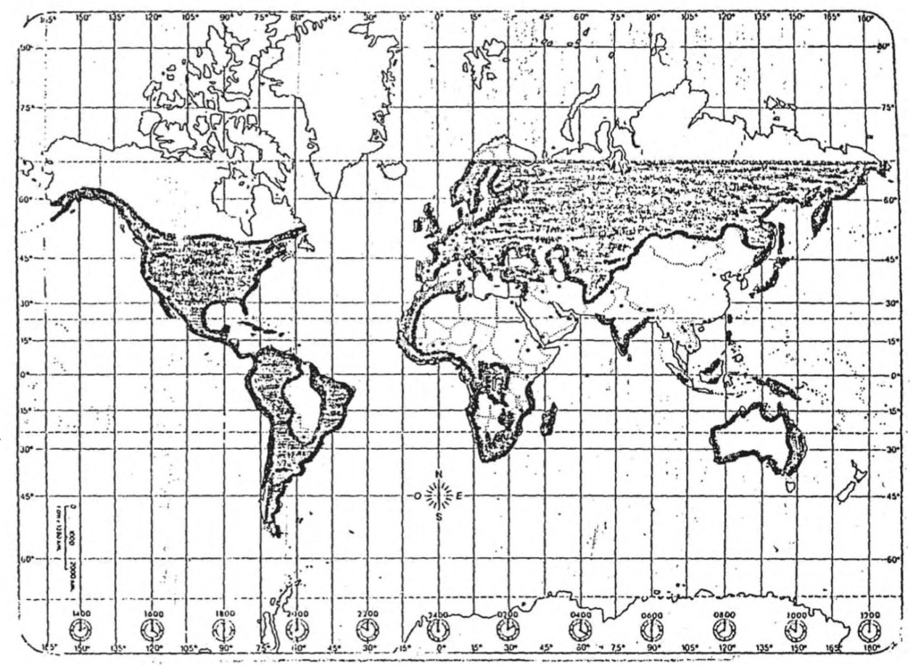

Figure 110

This objective has been proposed by the Hyperborean Siddhas for thousands of years, but only recently, thanks to the Esoteric Chorology of the and its discovery of a Route of the Kaly Yuga, has it been possible to comprehend the occult reasons behind it. And that is why, based on the Hyperborean Wisdom, which is the mother of the sciences of the , we can aArm that the Führer’s General Strategy contemplates a last aTack on the West by the Tu- ranian races, before reaching the end of the Kaly Yuga.
That time it will be the Siddha Anael who, at the head of enor-
mous Mongol armies, once again hoisting a banner with a Polar Sign, will irresistibly advance along the Route of the Kaly Yuga. But the li#le Judaized men, sunken into the darkness of blood confu- sion, will not see the Sign or understand that the end has arrived. They will believe until the last moment that they witness the ad- vent of the Synarchy and will foolishly rejoice in it. They will only react when, incredibly, from Berlin, they see arise an army of im- mortal men who wear the uniform of the eternal . But then it will be too late, for they will deploy in all directions, possessed by a Berserker Fury . . . and will only respect the sign of the Pure Blood.
- Christopher Columbus’ Hebrew Strategy

A Strategy of the Siddhas consists, then, in “pushing” the Hyper- borean Lineages of White Race “toward the Kaly Yuga” by employ- ing, for this purpose, the Turanian Races, coming from the center of lesser intensity, as a “tactical mass.” In order to prevent such an ob-
1028

jective, the Synarchy has at all times procured to keep the horizon of the Kaly Yuga “at a distance” by deepening the exploration of the Regions of the Path. And with such a motive, one of its infernal agents, a Jew known as Christopher Columbus, in the fifieenth century, prolongs, in the fifieenth century, the European transit toward Region VI of the Route; see Figure 109.
This is the secret objective of the “discovery” of America, which we mentioned when outlining Dr. Dee’s Project Thule, but which was then impossible to explain without resorting to the elements of Esoteric Chorology, such as the geochronic concept of the Kaly Yuga or the Chorography of Figure 109.
The Synarchy has thus tried to ensure that the Strategy of the Siddhas—“to march toward the West and then to return, by Blood and Fire, toward the East”—is hindered by the water barrier that the Atlantic Ocean places between Regions V and VI. In this sense, the “discovery” of Columbus has been successful (but this is rela- tive, since England and Ireland, for reasons that we will not discuss here, respond to chorological characteristics of an authentic Region VI, a quality that has enabled leaders such as Napoleon or the Führer to plan strategies that exclude America as a war objective).
- South America’s Mission in History

In Figure 108, a tri-continental triangle has been outlined, the vertexes of which are located in Peking (Asia), Algiers (Africa) and Buenos Aires (América), and which, taking into consideration the continents’ initials, is called: “the three As.”
We already spoke, in the “Second Dissertation” of the Secret His- tory of the Thulegesellschafi, of the Anael Order of South America, founded by the Hyperborean Siddhas afier the catastrophe of the Second World War. According to the directives given to the Order in 1946, the Siddhas would promote in the world three focal points of conflict outside of the Synarchy’s control. These three focal points would not be located on the Route of the Kaly Yuga, where the par- ody of an East-West “confrontation” would be executed in order to favor the Synarchy’s plans of World Government, but outside of it, and that is why the peoples involved in the conflict would be called “Third World” or “supporters of the Third Position.” The three focal points, which in the ANAEL Order were denominated as “liberation vertexes,” went into effect afier a few years: that of Peking in 1949, afier the revolution of Mao Tse-tung; that of Buenos Aires in 1946, afier the electoral triumph of President Juan Domingo Perón; and that of Algiers in 1962, because of its independence from France.
In order to comply with the proposed objectives, these “libera- tion vertexes” should be organized on the basis of a National Social- ist or Fascist principle, i.e., with a policy that favors social justice
1029

“inward” and defends national interests “outward” from the bor- ders. But the principal thing would be that, starting from the liber- ation vertexes, the conflict would spread to other focal points of similar social composition. Such an effect was sought not to favor “the revolution,” since such a National Socialist liberation move- ments would operate outside of the socialist, communist, or Trotzkyist internationals, but to balkanize the areas of conflict with myriads of “independent” or “liberated” countries that would render inoperative, with their contradictory votes, the United Na- tions or any other similar synarchic organization.
The Chinese Revolution achieved this objective in Asia, but its most important role was to prevent a Russian invasion to the cen- ter of lesser intensity, which could come from the USSR itself or from Southeast Asia. ANAEL’s Directive of 1946 was saying: “China and Africa constitute the body of a New World Order that will arise from the chaos of the West, but without the pressures of the Kaly Yuga” and then: “Hispano-America will be the head of that new civi- lization, the Will of the Siddhas is commi#ed to it.”
China and Africa fulfilled their part of the Siddhas’ plan in the
50s and 60s: what then occurred with Hispano-America? Here the project was not new, for already in the nineteenth century Simón Bolívar had understood that without a South America united in pursuit of nationalist and patriotic objectives it would be impossi- ble to resist the pressure of the great imperial Potencies, and with- out such a union, any possibility of political, economic, or cultural independence would be a pure utopia. The ANAEL Directive for Hispano-America was based on similar considerations and that is why, from 1951, powerful spiritual forces converged on three impor- tant personages who were fundamental pieces of the Hyperborean Strategy: we are referring to the Chilean president Carlos Ibañez, the Brazilian president Getulio Vargas, and the Argentine president Juan Domingo Perón. These three leaders tried, between 1951 and 1954, to carry forward a geopolitical plan denominated “ABC” (Ar- gentina – Brazil – Chile), elaborated by the Anael Order of Brazil, which consisted, simply, in forming with the three countries an axis—the inclined “L”—that would allow resisting the pressure of the Anglo-American imperialism. The ABC axis was contemplating the political, economic, and social integration of the three countries who would thus consolidate the third “Liberation Vertex.”
Naturally, that plan failed afier a sinister conspiracy would lead
Getulio Vargas to suicide in 1954 and another no less sinister synar- chic counter-revolution overthrew President Juan Domingo Perón in 1955.
What are the current alternatives of the Siddha Strategy for the Third World? We could say, chorologically, that the Triangle of the three As has “rotated” and that its vertexes now point to other spir-
1030

itual centers: the Peking Vertex has moved to the “Kaly Yuga’s cen- ter of lesser intensity,” in Mongolia; the Algiers Vertex is now in Tripoli, Libya; and the Buenos Aires Vertex, although it is not yet completely clear why, has moved to Santiago, Chile. From this last country will arise, then, the head of a new Hyperborean Civiliza- tion of a tri-continental scope, although, in order to do so, it must first rise above the nations of Hispano-America and convoke them around a joint project of liberation.
The Current Secret Route of the Kaly Yuga and the Triple “A” Tri- angle. Santiago – Tripoli – Ulaanbaatar
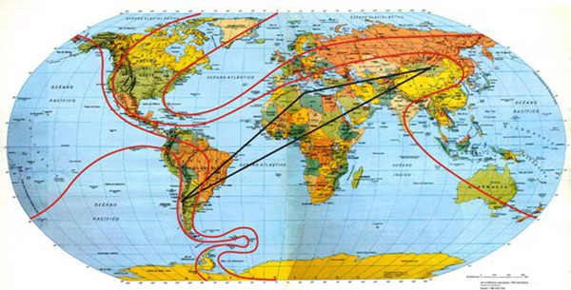
Figure 111

1031

