
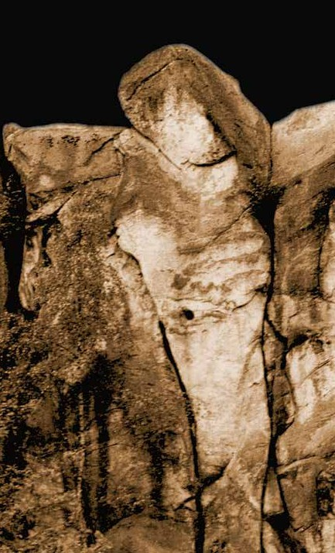


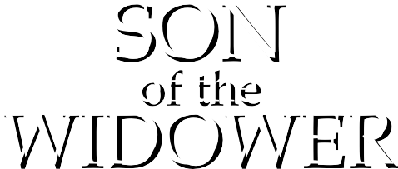


The Son of the Widower

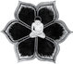
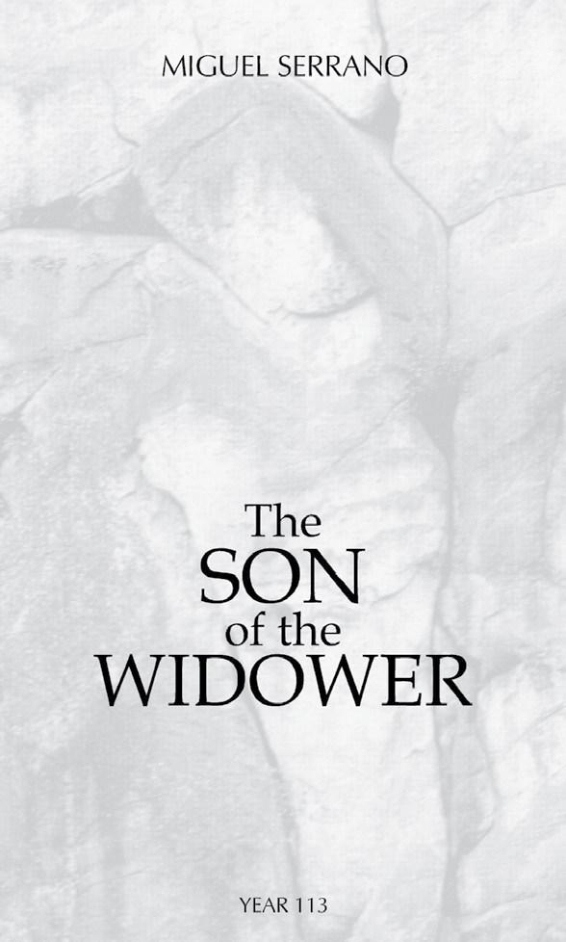
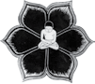

Originally published in Spanish under the title EL HIJO DEL VIUDO
by Ediciones La Nueva Edad, 2003

English Translation by
Roberto Jaras Lira

c Miguel Serrano, 2003
Inscription Number 130.626 All rights reserved

First English Edition 2003 Ediciones La Nueva Edad

PRINTED IN CHILE
Design by Carlos Videla Briones This book has been set on Bond paper and typeset using Times New Roman font Limited Edition

I.S.B.N.: 956-291-931-5
2

3

o
The Son of the Wid

“When children are born with their eyes open, the end of the world shall be near”.

Hesíodo

5
The Son of the Widower

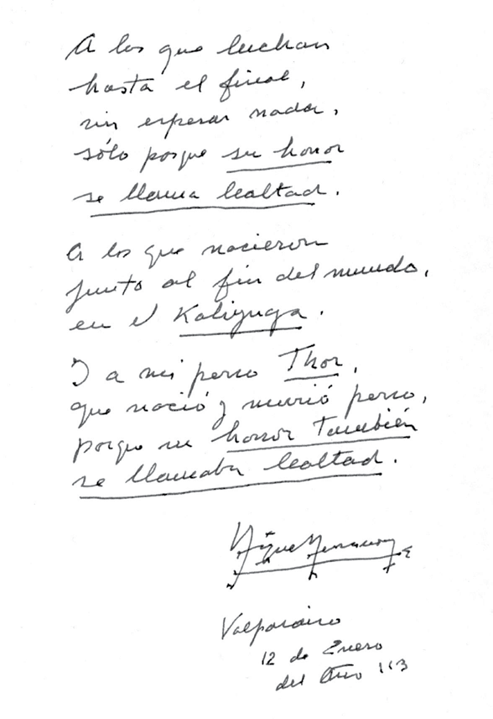

THE CATASTROPHE
The Son of the Widower

Today is December 25th, 2002 of the Judeo- Christian Era. The Christians celebrate the birth of a Child- God they call Jesus, who will later become the “+RISTOS”. For almost twenty centuries this has been imposed, insisted upon, believed. For those who were born and lived under this belief, it would seem impossible to think that it is not true, that none of this ever happened, that this temple- construction is based on a carefully elaborated lie, forged since its beginnings, and later modified and projected by the Archetype.
And it is precisely now, after two thousand years of imposing the most terrible sense of guilt upon the Western Aryan world for the murder of a “God-Man” and destroying old cultures and pagan civilisations in his name, here in America and throughout the entire globe, that these very same manipulators, who enslaved the soul of almost all the Earth, are announcing that none of this was ever true, because the bases of that story, of that “tale”, never existed. And for this, they rely on the most recent archaeological and anthropological investigations.
7

8

Miguel Serrano

Neither Abraham nor Moses ever really lived; nor David or Solomon were ever kings. There was never any captivity taking place in Egypt, much less a crossing of the Red Sea, or the tumbling of the walls of Jericho. That is to say, the whole Old Testament is an invention, a forgery. There were no twelve tribes of Israel, or anything like it. There never was an empire, nor a fatherland in Palestine. Now then, if the Old Testament is an invention, an imaginary story, then the New Testament, the Gospels
- based on the Old - are also invented. If Abraham never existed, nor Moses, or the Tables of the Law, or the Ten Commandments, much less did Joseph, Mary or Jesus of Nazareth. The Evangelists were authors to a “soap opera”, as someone would say today; that, or a bunch of skilful “politicians”, conspiring to overthrow the Egyptian, Persian and Roman empires, being thus able to impose a minority, a Gypsy-like tribe, over the rest of the “two-legged animals”, by means of their cunning and their deceit.

The Son of the Widower

THE RABBIS

The press tells us that the United Synagogue of Conservative Judaism of the United States of America, through an official document, is questioning those assertions made in the Old Testament. David Lieber, from the Los Angeles Jewish University, in a publication called Etz Hayim (“Tree of Life”), changes the Bible's version page by page, based on the latest archaeological, philological and anthropological discoveries, and introduces forty one essays written by rabbis and academics on the Torah manuscripts. Lee Levine, a professor of the Jerusalem Hebrew University, declares that there are no Egyptian documents referring to the captivity of the Jews and that the Exodus never took place, nor did the conquest of Canaan, or the Jerusalem of David and Solomon. On his part, Robert Wexler, President of the Los Angeles University of Judaism and author of Ancient Near Eastern Mythology, sustains that the account of the Genesis does not originate in Palestine, and may have its roots in Mesopotamia (now Iraq) and the Gilgamesh epic. Thus, Noah never existed either.
9

Miguel Serrano

The New York Times has also made reference to this in an article by Michael Massing on March 13th, 2002. Furthermore, in 1988 a Canadian newspaper published a chronicle by Eliezer Oren from the Ben Gurion University, where he states that the excavations taking place in eighty sites throughout Jerusalem contradict those assertions found in the Bible. And in Germany's Der Spiegel, three pages appearing in a June 1987 issue conclude that the books of Moses are merely “science fiction”.
We could go on quoting authors and publications on this extraordinary subject, which, nevertheless, seems to have passed unnoticed by the majority of people, although surely not by a minority of scholars and a governing elite who uphold world power, being those who really count.
I still hope that someone who reads these lines, and for whom I am making the effort to write them, understands the immense seriousness of what has happened. For nearly two thousand years, the world has been kept living, dreaming, suffering, rejoicing, killing and dying, building their lives and deaths over a lie, over something that never existed, over a carefully elaborated legend and myth. And now, all of a sudden, those very same who invented and sustained it over time, from one day to the next simply state that none of this ever existed, that it was all false. What has lead them to induce this catastrophe, almost simultaneous to and even worse than the collapse of New York City's Twin Towers?
It is believed that the scientific investigations of Middle-Eastern archaeologists and anthropologists may
10

11

The Son of the Widower

have induced the rabbis to support these statements so as not to appear irrationally opposing the assertions made by science. However, we do not find this to be a convincing argument, since, with all the enormous power in their hands, they could well refute those archaeological statements, ignore them or even make them disappear, like other certainties in previous centuries. No! There is something more to this, much more terrible and obscure!

THE ROBOTS
The Son of the Widower

Will we dare to penetrate the darkness of the greatest mystery of all? Who are the Jews, really? For Alfred Rosenberg, they are the organic lie. And Nicolás Palacios, author of Raza Chilena, years before, in the beginning of the 20th century, also sustained that: “the Jew can never tell the truth”, recommending that before reading a book, we should find out about its author and, “if it's a Jew, do not read it, because it is false”.
Among the millions of beings populating the Earth, what is a Jew? He's not an animal (although he could be a sheidim1); he is not a human being either. He is most probably a “robot”, at the service of an extraterrestrial being, Jehovah. And as such he has to carry out his orders, if he is to continue in existence. Thus, “god's people” come into being, of Yahweh, Saturn, Sat-an (Satur-day, Sá-bado, Sa-bbath).
Jehovah lives and feeds on the blood and flesh of the Earth's inhabitants. His “agents” describe him in their
13

- A cross between animal and man, according to the Bible. With age, Jews start developing animal-like features.

Miguel Serrano

biblical myths when Abraham is willing to sacrifice his son to feed Jehovah. The wars, the great killings, are banquets to Jehovah. And as the Kaliyuga approaches its end, that obscure Demon (that Archon), increases his appetite and is in urgent need of a final banquet, being that in over fifty years -since 1945 - he has only been feeding with small wars. He is fasting! Jehovah needs a new World War, where the Aryan blood of the goym2 is massively spilled. On the contrary, he runs the risk of disappearing as Satan, Saturn, the Archon imprisoned by the Demiurg.
Therefore, it is necessary to create an untenable world situation that leaves no other option but a great war. The economic crisis is inevitable without the Middle Eastern oil; the destruction of the New York towers gives the USA (this is, the Jews) planetary control, under the pretext of a “war against terrorism” (“those who are not with us, are against us”). And, finally, the collapsing of the spiritual world of the West, leaving the Christian church leaders and the very same Freemasonry without an ideological support.
The rabbis, who also seem to have demolished their own beliefs, already have a new instrument to oppress and dominate the non-Jews with; another spare “religion” to torture the Aryans and their senses of guilt: the Holocaust Religion. If Christianity accuses the goym of killing a God, the “Holocaust” blames them for murdering “God's People”. The first was utilised to accuse the Egyptians and the Romans. These are now replaced by the Germans, as
14

- Non-Jews.

15

The Son of the Widower

submitted as the previous, accepting meekly and doing penance in the “Museum-Temples” of the Holocaust, of the new religion, in spite of knowing that deceit was also present from the beginning. Because, just like the ancient Jewish religions and beliefs were based on falsehood, the new Jewish Holocaust religion, with its six million sacrificed (the number six is archetypal in Judaism), is another lie, even if its “dogmas” are blindly accepted by the non-Jews. The Demon Yahweh projects his hypnosis over the goym, thus helping “his people” of robots - but only until they have prepared his Banquet successfully.
And what if they cannot induce a Third World War? What if they fail? Could the new religion serve them as consolation, keeping their own people together, in spite of the growing discredit that is rapidly spreading throughout the world? That remains to be seen. In the end of all things, at the nadir of the Kaliyuga, their famished god would also abandon them.

The Son of the Widower

THE CHRISTIANS

One should ask oneself: if all of it was a lie, if two thousand years were built on legends and myths, what happens with the Romanesque and Gothic cathedrals, with Bach's marvellous music, with the paintings of Leonardo and Michelangelo, all created over those myths? How is it possible? And the saints and mystics? A Saint John of the Cross, a Saint Theresa, a Saint Francis of Assisi, an Ignatius of Loyola and the very Father Pious? All for nothing? All worthless?
It is here where another mystery comes to intervene, completely unrelated to the deeds of men and those of the biochemical robots. It is the strange intervention of the Archetype and his incarnation, or reincarnation, on Earth.
Already Paul - Paul of Tarsus -, who “did not meet Jesus”, had to borrow from Mythraism to set up his Christian story. And the Archetype of the Greek Kristos appears to him - and possesses him -, being no other than the incarnation of the Egyptian Horus and Osiris, of the Hindu Krishna and of the Avatara of Vishnu and Shiva. Later, and already having settled within the Church of
17

18

Miguel Serrano

Rome, through the Visigoth, Merovingian and Saxon Popes, the Germanic god Wotan also makes his appearance, being crucified on the Christian log, as he had been earlier on the pagan Tree of Life, the Iggdrasil of the Externsteine.
It is over the successive councils that the dogmas are created, incorporating small portions and hints of the archetypal revelation, unfortunately hiding the essence. We will never really know if an ecclesiastical minority ever kept the secret thread of the Mystery for itself, as an initiatory cult, able to transform, redeem and save this minority at the moment of the deepest future crisis.

The Son of the Widower
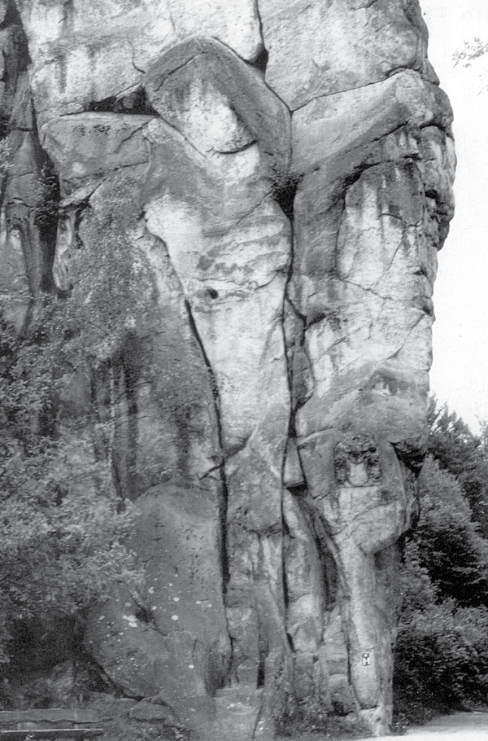

Wotan, “crucified” in the Externsteine.
The “Magical Death”.
19

ESOTERIC KRISTIANISM
The Son of the Widower

In India, a predestined child is born; his name is Krishna (Krishna-Kristos). The tyrant Kansas, being warned that this child would endanger his kingdom, orders the killing of every child born on that day. His mother, being prevented on time, manages to save him by running away to the city of Vrindavan.
The influence of India has been decisive in all South-eastern Europe and in the African Middle East. Hindu Emperors, according to the Count of Gobineau, would have established the very same Egypt of the Pharaohs. These traces, very visible two thousand years ago, were erased by the Jews, the Christians and the Muslims.
In Nazareth, Galilee, a child is born under the name of Jeshua. The tyrant Herod, after being warned that some day this child would endanger his kingdom, orders the killing of all those born on that day. His mother is able to save him.
The story of the Christian hero is a syncretism, a palimpsest of many personalities and events that are taken and mixed. Possibly, the life of a Zelotes, son of Judas
21
17

Miguel Serrano

of Gamala; a guerrilla fighter against the Roman Empire who may have been executed, perhaps crucified. Then, an Essene Master, influenced by Buddhism, who preaches love and equality in the Dead Sea regions. From Mythraism, highly popular among the Roman legions, the bread and wine ceremonies will be taken, from the banquets for the Sun God, which will later become the mass (from messe, harvest), dedicated to the God-Father. Alexandria's Gnosticism will also contribute with the concept of Devil (Demiurg), extracted from one of the Abraxas God's halves. And from Tao and Tantra, from China and India, comes the concept of the “Resurrection of the Flesh”.
If in the beginning all of this was done by men, brilliantly elaborated and planned, they were inspired by someone, who used them; someone who knew. That, or the Archetype, from outside, from far away, from above, or below, from the Inner Earth, from the soul of the Earth. Because history repeats itself, as we have already seen, in different places of the world, and throughout time. And if in the beginning the secret of the Initiation - which the revelation includes - may have been known by a Master, then, shortly after, it hides from the masses and disappears, apparently forever, even to that minority.
What this secret is really about is the recovery of a lost Totality, of the Total-Man, of the Absolute Self (of the Selbst of Nietzsche and Jung), of the Unus Mundus. At the beginning, it is said: “Me and the Father are one and the same Person”. Me and Brahma (the Guru and Brahma). But, as progress is made in this difficult path and

18
22

The Son of the Widower

the ego begins to become conscious of the Selbst (this is, of the astral body, updating it, making it visible), therefore expanding the ego, totalling the person, aspiring to the Absolute Self, becoming closer to the parting from the Father, which is fulfilled by the mystic death (this is, the crucifixion): the conscious detachment in the revitalised “astral body”, which is experienced as a voluntarily accepted and induced death of the rational, conscious ego. Then, Jesus is Kristos, the Absolute Self, with a “Super- Consciousness”, united to Kristos, to the Selbst, to the Self. He then tells the Good Thief (who is also Hercules, who “steals” the golden apples in the Garden of the Hesperides, and is Parzival, who steals the Gral, because all of this, at that point in Hyperborea's involutioned3 time, is the equivalent of a theft, and Totality then can only be stolen); he tells him: “Tonight (it is during the night that the astral body becomes detached) you and I will be at the right of the Father”. Yes, because he will no longer fusion himself with the Father, he will no longer lose himself in Brahma. He is now forever his own Self. “Me and the Father are not the same Person”. And it may be even possible that he can “illuminate the darkness of the Creator”…
After this “death”, the resurrection of the flesh will come, which is the “going out in the astral body” while the physical body “remains as if dead” (Wotan, on the Iggdrasil Tree, after nine days). But it also is the real resurrection of the body in the grave (the “materialisation of the astral body”); Jesus-Kristos, after three days, when his grave
23

- As in “involution”, the opposite of evolution. (Translator´s note).
19

Miguel Serrano

is opened and found empty. The Magus has been able to reabsorb the energy of the flesh and transfer it to his astral body, covering it with an immortal, indestructible red substance (Vrâja). This Man has given birth to his subtle, astral body; the Son of Man, as Jesus-Kristos was called. Jesus has joined Kristos, becoming a Boddhisattva, a “resurrected” being that remains on Earth to help his disciples, without yet entering Nirvana. When the graves of the ancient Taoist magi were opened, the body was not found either, but a Sword in its place. It was Excalibur, because they had been victorious in the combat for the recovery of immortality.
In the Christian legend, the story of the Pilgrimage to Emaus is a beautiful one. After the “death” of Jesus- Kristos, the disciples travel woefully, remembering the Master. Suddenly, a man joins them and begins to talk to them, using Jesus' same words. This puzzles them, but they do not recognise him (because the “resurrected” are not the same as the living, the “astral body” only resembles the physical body, its sides are switched, and the pupils of the immortals are square). And it is only during supper when they discover him, “by the way he parted the bread”. Then they say to him: - “You are the Master!”. - “Yes!”, he answers. “But, do not touch me!” (Noli me tangere!) For if they had done so, a deadly discharge would have occurred. Thus, Kristos, for a while, was also a Boddhisattva on Earth (it is said that for forty days)4 , after resurrecting his body, going into Eternity with it.
24

- This number is taken from the Egyptian Book of the Dead.
20

The Son of the Widower

THE MAGI ARE NOT CREMATED

In India, the fact that the highest Yogis were not cremated always called my attention.
When in Hyperborea the Siddha (and the Divya) loses his ability to materialise and dematerialise (thus causing the sinking and disappearance of Hyperborea and its Golden Age), the Aryans begin cremating their dead. Thus, they liberate the astral body (unresurrected in this life) sooner, and offer its energy to the Sun, through fire. However, the most advanced hierophants and a few Viryas (heroes) are not cremated, but buried - in the dust, or in ash-wood sarcophaguses -. They will resurrect. Where the body once lay, now a Sword will be found.
Furthermore, I witnessed yogis in India who were buried alive for an entire week, to then “awake” once more. But this is not the same. It is more like an “imitation of the truth”, the imitation of the resurrection.
With the arrival of Christianity, cremation is prohibited and all the dead are buried, thus ignoring an exclusive rite. Also, the mummification of the bodies signifies an attempt to preserve the form, when the ability
25
21

Miguel Serrano

of authentic resurrection has been lost, or its fulfilment doubted. And it is in Egypt - and also among the Inkas - where its apotheosis is reached, almost black magic-like, by keeping the Ka - the Astral - magnetically linked to what was once its form here on Earth, unable to liberate itself and look for another incarnation, by which to be able, perhaps, to achieve the “Resurrection of the Flesh”.
Moreover, it seems that something unknown and sinister might have existed in the mummy. Something related to cannibalism, searching to extract from the spinal cord, the cranium and the blood atom, a biochemical substance (Tulu, from Thule), allegedly similar to alchemical gold, to the aurum potabile that is drunk, with the purpose of prolonging life and strengthening the shakras. The members of “Skull & Bones”, the secret sect of the Yale University to which the presidents and leaders of the USA belong, should know about this.
With the prohibition of cremation and the generalisation of burials, everything among the christianised Aryans becomes confused. In the very same India, the Jewish woman who took over Sri Aurobindo Goshe's Ashram and called herself “The Mother”, in Pondicherry, did not cremate the great Yogi Sri Aurobindo and mummified him, being that she should have buried him for his resurrection. This way she carried out her revenge until the very end, impeding the fulfilment of the ultimate goal of Aryan Initiation: the Resurrection of the Flesh.
26

22

The Son of the Widower

SALVATION

I have tried to explain, to unveil, what may have been the Kristian Initiation, or what it could come to be, as the only means that a minority would be able to save itself, and all which the Archetype stealthily introduced in between the gears of Judaism, the sense of sin and of dogmatism. The great cathedrals, Leonardo's Annunciation, Michaelangelo's own Moses and Bach's Art of Fugue would have also been projected this way. And not all of it would have been in vain, a simple, non-existent game, a worthless effort, an illusion. And thus, this final revelation's mortal blow, of the non-existence of the fundaments of the Judeo- Christian doctrine, will have been neutralised the only way possible, revealing the Esoteric Kristianism, for the benefit of a minority, which is the only capable of salvation at the end of time. For nothing can be obtained now by going back to the most ancient doctrine, before the Second Vatican Council, as intended by some tendencies of contemporary Catholicism. All of that was precisely responsible for the vulnerability of the millenary construction. That which has been faintly pronounced by the Archetype, as if a whisper;
27

28

Miguel Serrano

not for everyone to hear, but always with a quiet voice, for a hidden minority, perhaps in Benedictine and some Jesuit monasteries, or the very Dominicans, who once created the Inquisition. And, from these would spring only one or two initiates, capable of recovering the Totality of the Selbst, of the Total-Man, of the Man-God, after having completed the authentic “Imitation of Kristos”. “Lazarus (the astral body), rise and walk!”. After the crucifixion, or mystic, magical death, where the ego has become conscious of itself, now forever separated from the Father, it is no longer reabsorbed and dissolved in Brahma, but “sits to his right”, with the possibility of resurrecting his own flesh, covering it with the immortal Vrâja and uniting it with the astral body, making it visible at will, but “without touching it”. (Noli me tangere). And thus, birth has been given to the Son of Man. This is what they truly meant, knowingly or unknowingly, the Popes of old, when they spoke ex catedra, referring to themselves as “Us (Nos), the Pope” (The I united to the Astral, to the Selbst), for they were One, in the Kristian Initiation, inherited from Wotan, from Odin, from Mythras, from Manes and, above all, from Shiva. And when He spoke like that, the Pope was infallible.

The Son of the Widower

ARYAN KRISTIANISM

When Professor Carl Gustav Jung made reference to Kristianism, telling me Kristos and the Selbst were One, when he showed me his Gnostic ring, pointing out the transformation he had done to the symbol, to “kristianise” it, when he rejoiced with the proclamation of the Assention of the Virgin by the Catholic dogma, understanding that now Kristos would have his feminine counterpart, accompanied by Her, like the Ancient Gods, I believe that he was consciously referring also to the Tantric Initiation, where the woman, the feminine eternal, has a fundamental role in the deification of man, the Initiate, the Alchemist (the soror mistica, the amasia uxor of the troubadours in the Languedoc, the yogini and the walkyrie).
In this civilisation's most critical hour, in order to walk through these complex territories, using concepts and terms only comprehensible by a minority, it is imperative to make use of the language contributed by Jung, the only one who has come close to the essence, unable to take the final step only for his profession as a psychologist, his Protestant origin, and his Masonic connection. He did not recognise
29

Miguel Serrano

the “Astral Body”. It seems he ignored that the Selbst, the Self, is the Astral Body. Nevertheless, he spoke about the Archetype and, even if he never precisely stated what he understood by Archetype, since it wasn't the platonic concept, referring more to a “coating of the instincts”, their “visual representation”, so to speak, at the end of his days, in the prologue he wrote for my book The Visits of the Queen of Sheba, he states, for the first time, that the “Archetype is not a product of the Unconscious”, by which, although not openly, becomes closer to the pagan Gods of Antiquity.
And as the Gods never die (because the Archetype is one and indivisible), but are reborn and reincarnated, they will return with different robes, to repeat the same story, there where men try to come up with new religions, from the depths of the Collective Unconscious.
And no other thing occurred with Kristianism, as we have tried to explain.

* * *

And what is it that the “Gods” want? They keep trying so that man, the fallen Divya, the Virya separated from his divinity, can recover it, thus returning to the Lost Homeland, and they show him the way, even if they know that he will never be like them anymore, but something different, unknown in the Universe. Perhaps even “illuminating God's darkness”…
The Gods know this, and expect it, and wish for it.
This is why they help, thus repeating the eternal story…

26
30

The Son of the Widower
31

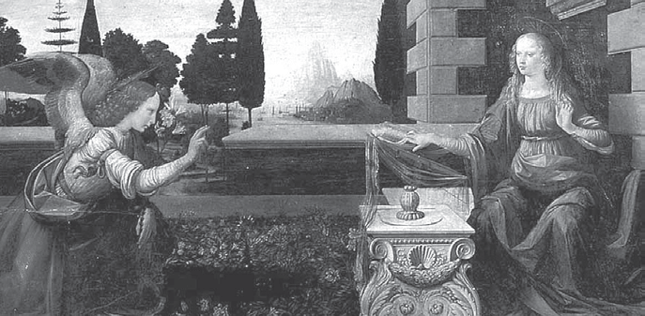
The Virgin Mary.
She becomes “pregnant” by the “Gaze”, and will give birth by parthenogenesis. (Painting by Leonardo Da Vinci).

ISLAM
The Son of the Widower

Islam will also be affected in its Doctrine by the destruction of its foundational myth. If Abraham never existed, nor did his son Ismael, then, who arrived at the Mecca to find the Kaaba? And who was that woman, Shaiba, that Widow, who gives her abode (next to the Kaaba) so that in it the new religion of the Arvasthans (arabs) can be founded, under the condition that her descendants are forever remembered as “the Sons of the Widow”? Once again we find here the conscious and decisive destruction of Hinduism's evident tracks. The Kaaba was a monolith, perhaps a meteorite, of immemorial antiquity, transformed into a Hindu sanctuary, in which the Sanscrit symbols and names of the Aryan Gods of Hinduism were inscribed: Brahma, Shiva, Parvati, Ganesha, the Elephant God, son of the previous, and of Indian Emperors such as king Vrikramaditya, who conquered those regions. The Queen of Sheba (Shaiba?) was also there. Sheba can also be the feminine counterpart of the Androgynous God Shiva, Ardhanasisvara. On the Pillar of Qutub Minar in Delhi there are inscriptions similar to
33
28

Miguel Serrano

those that existed (do they still exist?) on the Kaaba, on the Black Stone of the Mecca, of Arvasthan (Arabia). Arva is a Sanscrit word for horse, and Arvasthan is “land of horses”. Afghanistan, Pakistan, Turkistan are also Sanscrit names, indicating that these lands, now Muslim, once belonged to the great Hindu-Veddic Empire. Of all the inscriptions on the Kaaba, Mohammed only took the one of Allah for his only God. Perhaps because it can be read either way. It is a Sanscrit term, an invocation to the Mother Goddess, Durga. Allah, Akka, are used in the Hindu chants dedicated to Shiva's Wife and Mother. Allah is also ELELLA (HE-SHE), with Al being “EL” (HE) and lah, “ELLA” (SHE).
Thus, in those pre-Islamic days, the Arabs, strangers to the peninsula, are civilised by the Veddic Emperors and converted to the Brahmanic religion and civilisation. In the Istanbul Library, Makhtab-e-Sultania, there is a valuable manuscript found at the altar of the Hindu temple of the Kaaba that makes an account of all of this.
The Kaaba was a temple dedicated to the sun and the planets, adored through fire. The Mohammedans, who try to erase those memories, put the waning moon in their Emblem.
In their conflict with Jewish tribes of the region, the Muslims adopt the character of Abraham, made up by the Jews, being, furthermore, a pronunciation and spelling mistake of the Indian God Brahma. Truly, Islam, just like Christianity, is subtly penetrated by the Archetype of other beliefs and religions; by the Eddas, the Asen and Vanir sagas of the ancient Germans. From the Walhalla and the
34
29

The Son of the Widower walkyries it has taken the Jannah and the Huries. The
Ramadan reminds us of the fasting and asceticism on the festivities of Rama, the Ramayana. And the very name Islam can be broken into Is (the Goddess Isis, the Black; like Kali, like the Black Virgins, and the Kaaba itself), and Lam, the mantram corresponding to the Muladhara Shakra, of the sexual organs, pointing to a Tantric initiation now lost in Islam's surface, although perhaps not in its depths, which could be indicated by the existence of the Taj-Mahal, in India, and precisely by the name Kaaba (Cave, Great Mother, Black Stone). Lam is also way. Is-lam originally would have been the Way of Isis, of the Goddess Isis, of the Tantric Initiation of “Shaiba”, the Widow; of the “Queen of Sheba”, of the “Sons of Sheba-Shaiba”, of the “Sons of the Widow”, of the Black Stone of the Kaaba, of Shiva and Kali, of Ra and Isis, all Black (Nigredo). Of the Kaaba- Vimana (UFO). Because the vimanas were made of stone, and are thus described in the Ramayana and the Bhagavad- Gita.
These profound secrets were known and kept by the Sufis (Muslim initiates, Manichaeans and Gnostics) while they maintained their knowledge. In India I met some Sufis worshippers of Krishna and the God Shiva. Perhaps the “Ismaelites”, the Hassasins, of the Imam, of the Elder of the Mountain, also had a similar origin. But the Mohammedans, like the Christians, destroyed everything by imposing a ferocious orthodoxy and, as in the Inquisition, stoned the transgressors. They veiled the feminine eternal, even on the faces of their women, and in contrast to the jewel
35
30

Miguel Serrano

of their Taj-Mahal, a poem in marble and precious stones dedicated to Eternal Love (the A-Mor5 of the Hyperboreans and Veddic Aryans), they have invented the purda and the harem, and also destroyed the most wonderful relics and sculptures throughout the world, like the millenary stone Buddhas in Afghanistan.
Just like in Christianity, the Jewish penetration in Islamism has been the invisible hand, guilty of also installing here its inventions, which by being publicly exposed as false today, leaving the Islamic world likewise helpless.

* * *

The Arabs have also been penetrated by the Daggatum and Donmeh Jews, who have become among their people something similar to the Spanish Sephardim, Jews under disguise.
Nevertheless, the Arabs of Islam, just like the Christians, but even more than these, are in the position to overcome this great crisis for maintaining - for a secret initiatic minority - of the Mystery of the Kaaba and the Initiation of the BLACK SUN, of the BLACK STONE, which was once the occult link with ESOTERIC HITLERISM, during, before and after the last Great War.
36

- A-Mor, Spanish for love (amor), in this sense also means “without- death”.
31

The Son of the Widower

ESOTERIC HITLERISM

After their “Renewed Alliance” with Jehovah, that tribe of slaves, the Jews, who arrive with the Aryans in their exodus from the Gobi, crossing India all the way to the Middle East, little by little begin altering everything, infiltrating, with direct help from their God- Demon, Jehovah. In India, the Beni-Israel Jews remain, discretely (“camouflaged”); in Greece, they settle down in Macedonia, in Monastir, up to these days. Among the black people of Africa they are the Falasha; amongst the Chinese and Japanese, the Tiao-Kiu-Kiaou; in America, the Aztecs, with their bloody sacrifices, ignoring Quetzalcoatl; among the Arabs, the Daggatum and Donmeh, as we have seen.
When does the Jew become a genetic robot, a clone, a golem of Jehovah? Beyond doubt, quite before this “Renewed Alliance”, at the very moment of the appearance on man on Earth. The great risk taken by Jehovah, in order to succeed in this artificial, genetic “creation”, is that he needs of a certain mix with the “animal-man”. And it is precisely here where his experiment may fail - and sometimes it does -, due to the conflict, the internal struggle,
37
32

Miguel Serrano

between the “genetic machine” and its human portion, which, in the end, could even produce a catastrophic explosion that may destroy Jehovah himself. Moreover, there is the risk of rebellion breaking out in the Jewish world, of human versus robot, clone, golem. And this is known and felt by the great rabbis and by the very same Jehovah. Thus his increasingly urgent need to provoke a world conflict of immense proportion, one that distracts the Jewish mass from its own drama, and feeds Jehovah.
At the same time they are destroying the bases of millenary beliefs by revealing their falseness, the rabbis today are creating the new Holocaust Religion, to maintain their inner cohesion and paralyse the goym.

* * *

Professor Hermann Wirth, founder of the Ahnenerbe
- a superior institute for investigation of the SS -, knew all of this. He personally revealed it to me, during his final days, when he was writing his most important work on the history of the Jewish people, a manuscript that has been made disappear and which could now possibly be in the Vatican.
On the other hand, Professor Jung was preoccupied by the fact that the Western world “was interrupted in its development from Paganism by the imposing of another culture”. Without a doubt, he was referring to Christianity. He attributed the conflicts and wars to that inner dichotomy and those periodical explosions of the world repressed in
38
33

The Son of the Widower

its natural development. It was Wotan rising, the God of War, according to Jung. None of this ever happened in India, because that world developed without interference or interruption, from its polar and Veddic origins (Tilak).
Nevertheless, and for this reason precisely, man is less individualised in India, lacking the conscience of his own “ego”, wrapped in his own Collective Unconscious, so to speak. That is why, like the dogs and cats, the Indian never gets bored. Boredom is a product of the “ego”, being unable to create new ways of entertainment, of inventing them at every moment. On the other hand, the Unconscious is immersed within the millenary creations, living them, in permanent contact with its Gods, who speak to them. Therefore the Indian is never alone, but united to his whole people, who “think alike”, who have the same lives and beliefs. It's the Collective Unconscious. A Hindu is the same as the next, the opposite of Western man, all different from each other. Furthermore, Jung declared to me that Indians “do not think their ideas”. Ideas appear to them. Only Westerners, Europeans, create and produce their ideas. At least this is how they feel. “And this would have been the compensation for the inner conflict produced by the imposing of Christianity over the pagan world” (this statement is mine), “interrupting its natural evolution. The conscience of the self, the apparition of the ‘I'”. A case unique in the entire Universe.
The extraordinary event of Hitlerism is also unique in the history of the world, allowing a folk to consciously and willingly recover the interrupted evolution of the pagan
39

40

Miguel Serrano

universe and incorporate it to “Esoteric Kristianism”, to put it in these terms, uniting 7OTAN with +RISTOS; because both are one and the same person, the same Archetype, the same God.

The Son of the Widower

RECREATING THE SUPERMAN

Hitler said: “The one who sees our movement only as a political party, has not been able to understand anything. It is much more: It is the will to create (recreate) the Superman”.
To recreate Him; because the Superman is not a human state in a future biological evolution, as it is thought to be Nietzsche's belief. The Superman once existed in the past, and it was lost. There is no evolution, but only involution. To know more about the Cosmogony of Hitlerism, I refer the reader to my book Manú. Por el Hombre que Vendrá, to the chapter “Cosmogonśa Revelada” and its explanatory diagrams. Here we will only sum it up by saying that in the beginning, millions of years ago, the Divya appeared upon this planet Earth, where he had to adopt a form to be able to work, thus covering his subtle being with this denser matter. Only for a short terrestrial time, going back dissolving this form and disappear. And so on, continuously, until, due to a strange event, for “falling in love with the daughters of men”, the Divya loses his ability to disincarnate, becoming a prisoner of terrestrial
41

Miguel Serrano

matter, until he forgets his real origin and loses his powers, along with the use of one of the halves of his brain, an instrument created for the invisible Mind to work in this other plane. But not all have suffered this fate. Perhaps one was able to leave, after uniting himself with a woman, to reproduce, dividing himself (“from a rib”, as legend has it). And so it was that this woman became a widow, the Great Widow. Her descendants will be the “Sons of the Widow”, the Viryas, part divine, part human.
The “Sons of the Widow” will live in their essence, like Abraxas, the innermost tragedy of a fate full of struggles, being able to move in both directions, upwards and downwards. Like Parzival, the Son of Another Widow (of Herzeloyde), they will be able to find the Gral, this is, to become one with the Selbst, the Self, recovering the lost Totality; or else, to remain a prisoner of the Demon-Wizard Klingsor, in the Castle-Lodge of Schastel Marveille, where they will be under the Demon's hypnosis, until one day they may also free themselves by miracle of the Gral.
In the mixing of the Sons of the Widow with the “daughters of men”, reproduction will no longer be by parthenogenesis, but through the multiple-functioned bodily organs (“through pain”). Then, the Virya will progressively lose the memory of his origins, strengthening a terrestrial “ego”, also the unique product of the conflict between two colliding worlds. And the only way out to remain will be no other than the help that the Archetype-God, the Divya, may decreasingly provide, due to the mixing of the races, induced and spread by the Demon Satan-Saturn-Jehovah and his genetic robot, the Jew.
42
37

The Son of the Widower

THE SON OF THE WIDOWER

We will touch the centre of the Mystery of all mysteries.
What happens to Lucifer (the Lucibel of the Cathars)?
Why does he abandon those he has brought to the Earth?
For Lilith!
She is the Divine Woman, the first to break the Cosmic Egg, where she was one with Lucifer, out of curiosity, to know (cognosis) and to oppose the Demiurg, the one responsible for the Big Bang. Lucifer follows her, seeking to recover his counterpart, his Eternal Feminine.
He finds and loses her here on Earth. It has been said that Adam also knew Lilith, before Eve. We use these names to make the story easier and for the fact that these are archetypal characters, for this story eternally repeats itself, later on with Abaris the Hyperborean, and Allouine, in Greece, and even in my own life, in Chilli-Chile (see the second volume of my Memorias de El y Yo). Lilith is also the Queen of Sheba.
43

44

Miguel Serrano

The love (A-Mor) of Lucifer and Lilith (A = without, Mor = death; Without Death) allows for the wilful recovery of the Totality of the Opposites, of the Opposite Pairs, to be possible inside each of them; Lilith, united to her masculine animus, and Lucifer, to his feminine aenima, using Jung's terminology. Each is wed to his and her own Selbst, thus allowing the real Son of Man and Woman to be born (being “delivered” by the Man), the Astral Body, the subtle body, androgynous, the Shiva Ardhanasisvara. For this, Lucifer had to become Lilith's widower, here on Earth, and “pregnant” from Her, thus giving Birth to the Son of the Widower, the Astral Body (with the face of his Beloved) which, by being clad in a terrestrial body (for a short while) will make possible in this world the forthcoming of a cast of Warrior-Heroes, fighting to redeem the rest of the Viryas, of the Hyperboreans and Aryans, prisoners under the hypnosis of the Demiurg, with the help of Satan-Saturn-Jehovah and his genetic robots, the Jews, as it has already been said.

The Son of the Widower

AND THE SONS OF THE WIDOW?

These are the result of the mental contact between Eve and an extraterrestrial being, her first Husband, who then leaves, making her a Widow. Then, by “parthenogenesis” she gives birth to a Virya, called Cain by the Biblical Legend. The other sons of Eve will be “delivered in pain”, after the “deviation” of the Serpent Kundalini. Cain's descendants, the “Cainites”, are the “Sons of the Widow” who spread Gnosticism - from Gnosis, knowledge
- in the beginning, and also the esotericism of “Memphis Misrahim” of ancient Egypt. However, they will also be infiltrated by Judaism, in the Masonic Lodges, which in later centuries become centres of Satanism, responsible promoters of the French Revolution, of the so-called American Independence, of Marxism and the current Globalism. It is precisely there where the creation of the Robot-Messiah of Israel is taking place, the final clone- golem, who will rule the enslaved world at the end of the Kaliyuga, from the headquarters of his Empire located in the south of the world, from the 40O parallel all the way down to the Antarctica.
45

46

Miguel Serrano

However, with the destruction of Jewish mythology and legend, they will also be affected, since neither the Temple of Solomon, with its Urin and Tumin pillars, or their Great Architect, Hiram, nor all their Judeo-Masonic symbolism, ever existed. Moreover, for a small minority of Masons there will no other salvation than to return to the occult origin, resurrecting the Mystery of the origins6 and, just as the Christians and the Muslims, understand that they cannot fight the Sons of the Widower; for a Son of the Widow could also transform himself eventually into a Son of the Widower.

- The Builders of Menhirs and Cromlechs of pre-history and their heirs, the Aryan “great architects” of the Stone Age.
41

The Son of the Widower

THE SS BLACK ORDER

The belief that the SS were formed only as a Protection Corps for the Führer - “Schutz Staffel” - must be corrected, although this is what they appeared to be in the public eye. The real founders of the Order and of National Socialism, where even Himmler was a secondary character, had a different intention. The Left-turning Swastika, for example, which rotates on the opposite direction to the rotation of the Earth and points towards the return to the Polar Hyperborea, is revealing the intent to overcome man's involution, to “recover the Superman”, the Total-Man, the God-Man, the Divya of the origins. It is also the Swastika of the Bo, of pre-Buddhist Tibet. SS means Schwarze Sonne, Schwarze Stein, the Black Sun of the Tibetans and the Hyperboreans, of the Ainos, and the Black Stone of the Kaaba. Moreover, the black uniform, the skull and crossbones are a secret code, different to the one of that strange “brotherhood”, “Skull & Bones”, already mentioned. Inside the skull and the bones lies that mysterious substance, Tulu; but not to be eaten in a cannibal way, but to be
47
42

48

Miguel Serrano

mentally incorporated to the Astral Body, so it can facilitate the Resurrection of the Flesh. It is the "Vrâja"7.
Esoteric Hitlerism knew about the Kristian and Islamic Esotericism, and it was from that viewpoint that it related to the Mufti of Jerusalem and to the Pope Pious XII, who lived with a German nun at his side (his soror mistica), saw Hitlerism's Flying Discs and, surely, knew that “the virginity of Mary” was possible, having given birth to Jesus (just as Eve was, and how she gave birth to Cain) by parthenogenesis, telepathically impregnated by a Divine Being, a Divya, also his first Husband. That is to say, by the “gaze” of Leonardo's Angel. Thus, the legendary Jesus would also be the Son of a Widow.
In the Castle-Temple of Wewelsburg there was a select group of initiates who practised a secret western yoga, focused on the recovery of the Superman, the Total Man, with both his cerebral hemispheres active.
I was inside Wewelsburg's subterranean enclosure, with its twelve stone pillars-seats, around a circular area, reserved to Fire, which was lit to ascend up to an opening above, with a Left-turning Swastika; the Black Sun, the Astral Tube, through which the Astral Body, the “Son of Man”, should “come out”; the one who would be able to resurrect the physical body inside the warrior's tomb (the SS tombs, with the Man, Rune of Life: ) and once again populate the Polar Hyperborea, in Neu Schwabenland, the

- The skull and bones in the SS uniform symbolized the recovery of immortality, and the colour black is the “Nigredo” in the alchemic- tantric initiation, being different from other uniforms, as the Husar and the black flag of the Corsaries.
43

49
The Son of the Widower
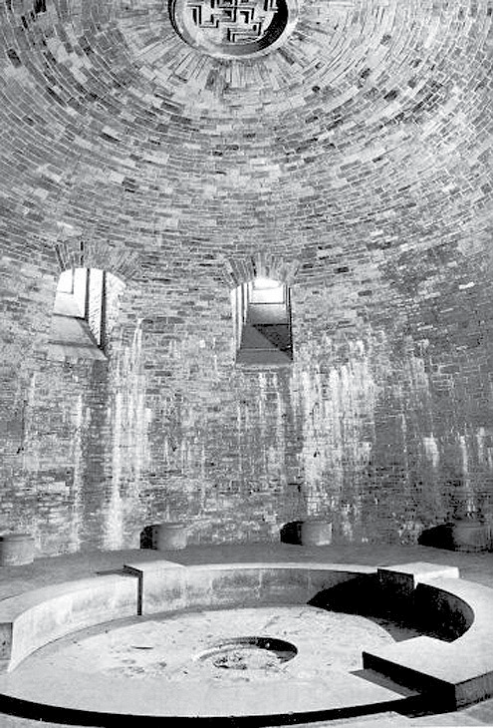

Central room in the subterranean enclosure of the SS Wewelsburg Castle, where the initiates detached themselves in their Astral Bodies. And the Son of the Widower “came out” through the Black Sun (“Astral Tube”), the Left-turning Swastika over the ceiling.

50

Miguel Serrano

Hitlerist base in Antarctica, in the Weddell Sea, in the Lands of Queen Maud, where the Supermen take off to the Venus Star and to Aldebaran, in their UFOs, or Vimanas; that is to say, in their round, materialised Astral Bodies, of immortal, indestructible Vrâja, assuming and dissolving their shapes at will.
The subterranean Temple-enclosure in Wewelsburg was a reproduction of the Solar Temple (of the Black Sun) of the first Kaaba, the pre-Islamic, pre-Veddic one, extraterrestrial.
A Spear, or imaginary Arrow, united the Wewelsburg Castle with the Externsteine ruins (Stern-Steine: “Stellar Stones: UFO”). And there Wotan was sculpted, crucified in the Iggdrasil Tree. And there is also an open Tomb, carved into the rock, where He resurrected.

45

The Son of the Widower
51

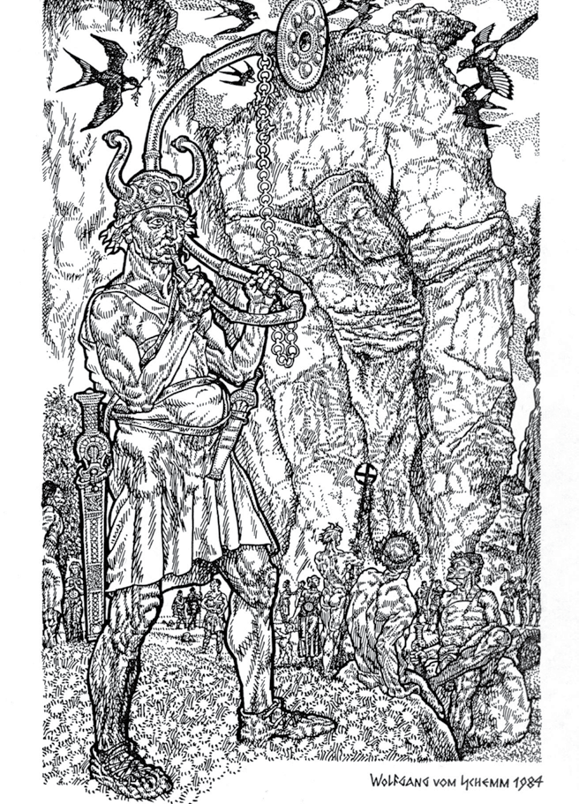

Wotan's warriors celebrate their Magical Death, in the Iggdrasil Tree, and their Resurrection after Nine Days, as a Son of the Widower. (Engraving by Wolfgang Von Schemm)

Miguel Serrano
52
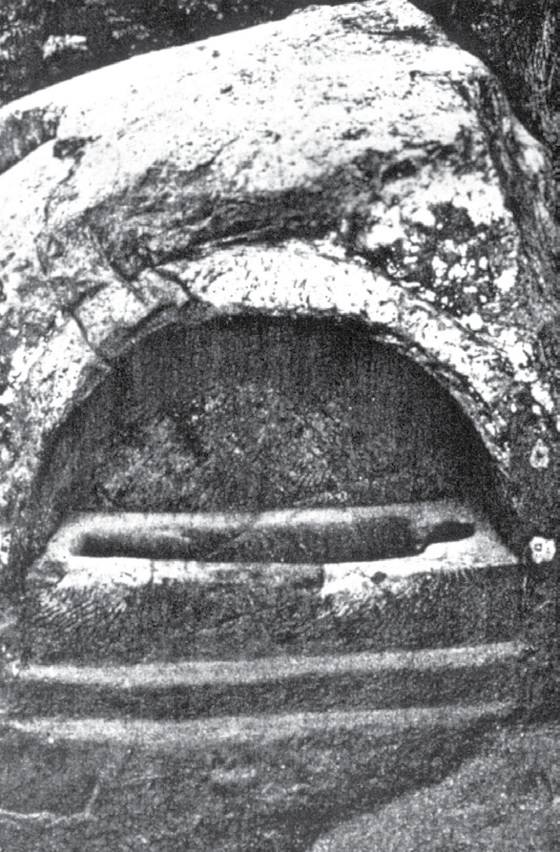

The open stone Tomb, in the Externsteine (Stern = Star - Stein = Stone). Here, Wotan was resurrected, in his immortal body, after Nine Days… “They found it open and empty…”

The S
53

APPENDIXES

UNBELIEVABLE!
The Son of the Widower

Something unbelievable! Diabolical evil?
Anticipating September 11, 2001, the twenty-dollar bill of the USA, in a concealed way, exactly reproduces the aerial attack to the Twin Towers in New York City and to the Pentagon, apart from the name OSAMA. This is something so utterly unbelievable and extraordinary that the “animal- men” do not seem to understand it, completely overlooking it without further reaction.
This is another sign, along with the 666 found in the UPS bar code, confirming that the Devil governs these final times of the end of the world.

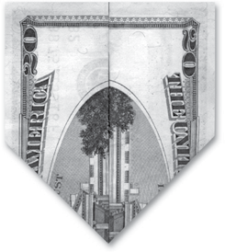
Fold it this way:

The Twin Towers appear in flames.
55

Miguel Serrano
56
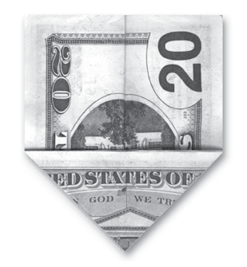
Turn it over to reveal the Pentagon, also on fire.

Fold it this way:
The name “OSAMA” is formed.
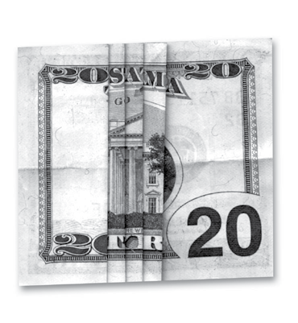

The Son of the Widower
57

S.O.S.

This is a sign used by Masons to announce their distress to their “brothers”.
An S.O.S.
This photograph appeared in a Chilean newspaper, and it depicts an important politician.
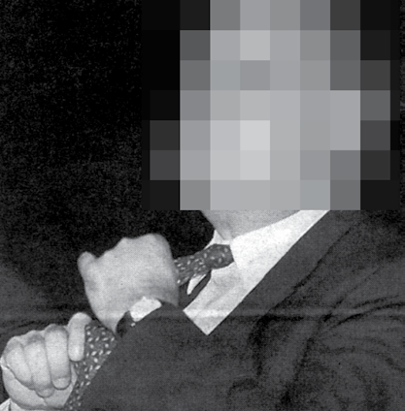

The Son of the Widower

INDEX

The Catastrophe 6
7
The Rabbis 8
9
The Robots 11
13
The Christians 14
17
Esoteric Kristianism 17
21
The Magi are Not Cremated 21
25
Salvation 23
27
Aryan Kristianism 25
29
Islam 28
33
Esoteric Hitlerism 32
37
Recreating the Superman 36
41
The Son of the Widower 38
43
And the Sons of the Widow? 40
45
The SS Black Order 42
47
APPENDIXES 48
59
53

