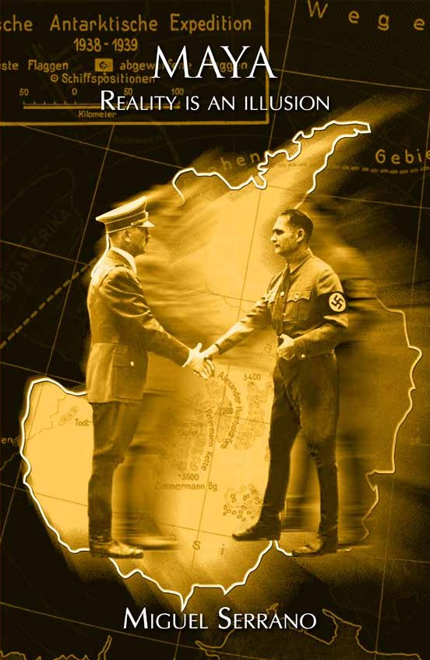

MAYA

Reality is an Illusion

MIGUEL SERRANO

- 1 -

Originally published in Spanish under the title
MAYA, LA REALIDAD ES UNA ILUSION
by Ediciones La Nueva Edad, 2005

English Translation by
Miguel Serrano Spaltman

©Miguel Serrano, 2005
Inscription Number 144.603 All rights reserved

First English Edition 2006 Ediciones La Nueva Edad

PRINTED IN CHILE
Design by Carlos Videla Briones This book has been set on Bond paper
and typeset using Times New Roman font Limited Edition

I.S.B.N.: 956-310-264-9
- 2 -

- 3 -

I dedicate this book to Adolf Hitler, the Last Avatara,
and to Martin Heidegger, a great German,

who was loyal until the end of his days.

- 4 -

He who regards National Socialism As merely a political movement, has understood nothing.
Nazism is an attempt to resuscitate the Man-God.

Adolf Hitler

Reality is illusory; it is Maya.

Hinduism

MARTIN BORMANN

Today, 17th of August of the year 115 of Hitlerian Era, 2004 of the Judeo-Christian Era, as we reach a new anniversary of the murder of the double of Rudolf Hess, in Spandau Prison, Berlin, I begin to write this astounding account.

Towards the end of the 1960’s I resided in Vienna as ambassador. The Foreign Relations Secretary of Chile was Gabriel Valdés Subercaseaux, a gentleman, possessor of all of the qualities of the old lineages of my country. We where destined to understand and appreciate each other. I received a confidential memorandum, signed by him, with a strange petition: Visit Simon Wiesenthal, who resides in Austria. This was the mendacious self-styled “nazi hunter”, who recently had declared to the London Newspaper The Observer, that Martin Bormann lived in Chile, and that “a Chilean diplomat had offered him Bormann’s passport for sale”.

The Minister asked me to visit Wiesenthal and request the name of the aforementioned diplomat.

- 6 -
5

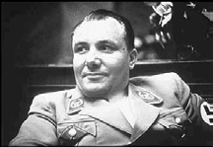
Martin Bormann.

Martin Bormann was Secretary General of the German National Socialist Party, for which reason he was with Hitler until the end, managing to escape the Bunker in Berlin at the last moment. Some versions state that he was killed in the streets; still others that he managed to escape to South America; or perhaps, that he was taken prisoner by the Russians.

The final truth about Bormann’s passport was made known to me under strange circumstances, which I have explained in my “Memoirs of He and I”. A woman who was friends with Bormann, in the south of Chile, had given it to a left-wing Chilean writer¹ (who was not a diplomat, and who had offered it for sale to Wiesenthal). This writer was later forced to leave Chile during the military government, dying under strange circumstances at a hospital in Bulgaria.

Again many years ago, during one of my last trips to Europe, I met in Germany with the former head of Counterespionage of the Austrian SS, Wilhelm Landig, author of the book: “Time of Wolves in Thule”. He was

¹ Enrique Bello, editor and director of a political-literary magazine in Chile.

- 7 -
6

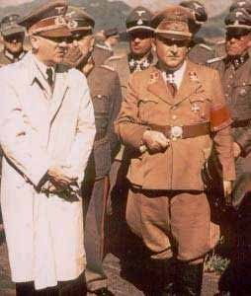
Martin Bormann with Adolf Hitler.

preparing a new book about a spy that remained with Hitler until the end, whose code name was “Werther”, and who managed to escape to Russia. He thought that this spy was precisely Martin Bormann, who would have died in Moscow “a short time ago”.

I refuted him, arguing that Martin Bormann had been in Chile and that he was not a Russian spy.

I was accompanied to the interview by the President of the “New Templars” of Austria, R. Mund, who was to become renowned by his book “The Rasputin of Himmler”. He listened to Landigs’ opinion about Martin Bormann and to mine, supporting Landig. Then he invited me to have dinner at his home.
7

8

What follows no longer seems to have occurred in this world, but in a reality of dream, or nightmare.

“It is necessary”, he told me, “that you speak with a very important person, a former engineer of Hitler’s secret weapons. He doesn’t receive anybody, it is not even known that he exists, but I am going to take you to meet him so that you can express to him your opinion about Bormann...”.

NIGHT IN AUSTRIA

It is nighttime. The city is in darkness. We walk until a dim light appears. It is a poorly illuminated kiosk, guarding a great door with a sign of “Coca-Cola”. I believe we must be lost, that this cannot be the end of our journey. Inside the kiosk there is a man wearing a short-sleeved shirt. With him are some papers resting on top of a board. Mund introduces him to me: he is the secret weapons engineer and this is the only job he has been able to hold without giving away his identity. He receives me with cordiality, as if had been informed about me and the purpose of my visit. To my question about what he thinks of Bormann he responds in the most unexpected and strange way, with another question: “Do you know who Hitler was?”.

Quite surprised I respond: “Of course I know! How could I not know?”.

“No”, he says. “You cannot know it, because nobody knows it, nobody knew it for a fact… Did you know that the Russians found fourteen dead bodies of Hitler in the Bunker and in the Chancellery, and all were the same? Which then was the one that they cremated in
9

the garden of the Bunker? Which one was the real Hitler? And which was the one that went to Antarctica? The same questions must be asked about Martin Bormann and Rudolf Hess… Who was the real Bormann, the one that was in Chile or the one that died in Moscow?”.
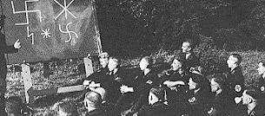
The SS receive instruction about ancestral symbols.

Never, in all of my years of struggles and battles, during and after the Great War, had I found myself in a similar situation. Here I am, in a ghostly night, in a dreamlike city, next to these two strange characters: one of them head of the Templars, and the other, creator of secret weapons in the Third Reich. Both of them experienced warriors, serious and trustworthy.

The engineer continues:

“–Did you know that we scientists of the Third Reich were more than a hundred years ahead in the discoveries of technology, mechanics and also biology? Did you know that not only the cloning and robotics were achieved, but also real duplication? Yes, duplication! And the perfect duplication. Then, who

- 11 -
10

was Hitler? Or who was Martin Bormann… the spy, or the other?”.

*****

Ah! Germany, the Germans, the Germanic race, the Arians! They are capable of everything, of transfiguring the world and the human being, if they unite and, above all, if a guiding Chief appears, like Wotan in the old times.
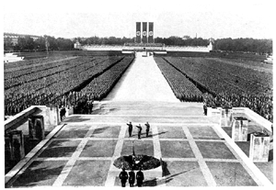
Never again have such ceremonies been seen.

Then they become Gods once again, semi-Gods, like they once were in Pre-History, in Hyperborea.

The duplication! Something that was precisely an ancient goal of these advanced people. In this sense, I recall a movie I saw when I was a teenager in the Barros Arana boarding school: Metropolis, from the early 20th century, in which a woman was duplicated by

- 12 -
11

means of a scientific experiment, making it impossible to know who the authentic one was.

Yes! Who was the real Hitler? Who was Martin Bormann?

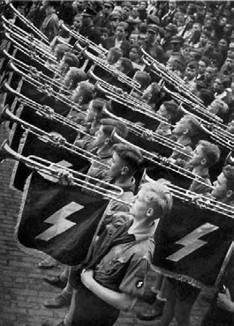

Hitler’s youth.

- 13 -
12

HITLER

It is in Mussolini’s Italy that the Archetype of the Emperor reincarnates in our times. That had occurred likewise with the Egyptian Pharaohs, the Indian Maharajas, the Germanic warrior-heroes, the Hyperborean Siddhas, the Incas, the Atumarunas, the Roman Emperors and the Pope. It is the mystery of the Archetype, something like an external Idea, that arrives and takes hold of a human being, or more than one at the same time, preserving itself in a Collective Unconsciousness, that occasionally becomes “Collective Consciousness”, thanks to the sacrifice of man that has been possessed, and that, in his utmost state of trance, or when he speaks ex-cathedra, no longer refers to himself as “me” but as “us”. And he says: “Us, the Pope”, wishing to affirm that he is one with the Archetype and that he speaks for everybody.

It was the incarnation of the Duce in Mussolini that made many others possible. This way, we see the appearance of guides such as Codreanu, Plinio Salgado, Oliveira Salazar, Primo de Rivera, Ledesma Ramos and even Jorge González von Mareés, in Chile. When all these “chiefs” have accomplished their mission or, in

- 14 -
13

other words, when the Archetype has accomplished His missions here, on Earth, fulfilling his purpose, the secondary guides are left without energy, so to speak, without a possible destiny, and they become lost or they end-up like an empty casket, sometimes in sad conditions like the case of Von Mareés.
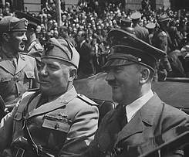
Hitler and Mussolini (the Fuhrer and the Duce).

We have said that the Archetype is something like a Platonic Idea, that seems to hang around the atmosphere of the Earth and is apprehended by the Collective Unconsciousness of human beings, thanks to the “sacrifice” of one human being, which due to his genes, or his karma, is worthy of being “possessed”.

Due to the purity of its race, it is not difficult to understand that it has been in Germany that the Archetype of the Fuhrer acquires a superior existence and dimension, that causes the “memory of the blood” to awaken with incredible strength, galvanizing an

- 15 -
14

entire nation that began to feel interpreted in every one of the words of its Fuhrer and was willing to follow him until the end.
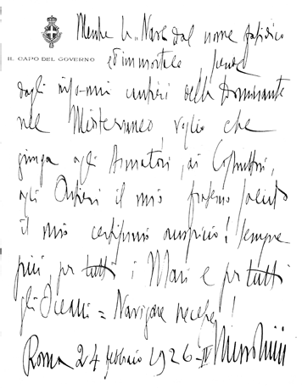
Manuscript of harangue, handwritten by the Duce Benito Mussolini, dated the 24th of February, 1926. It is addressed to the constructors and navigators, in the launch of a ship in the dockyards of the Adriatic.

- 16 -
15

It was precisely in Germany –where for centuries it was intended to intervene in the human biology– that a minority was able to activate the right hemisphere of the brain and resuscitate the Superman².

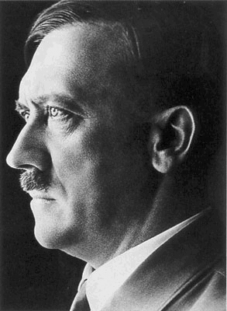
The Avatara.

² Translators note: Nietszche’s concept of Uber-mensch; Over- man… in Spanish “super-hombre” (superior man), which is not to be confused with the comic-strip character from the USA. Literal translation was preferred so as to purge this wretched association.
16

17

The incarnation of an archetypical idea made the appearance and presence of the Avatara possible and necessary; that is, of a God, of a Divinity: Vishnu, Osiris, Wotan, Kalki, who would have come to close a cycle on Earth, “Mounted on a White Horse”.

*****

It was in this way that the last Great War was not merely one more war in this world. It was something immense, definite, and those of us who understand it in this way have given ourselves to the combat, until the end of everything.

And it was a man, Adolf Hitler, who withstood in his body, in his brain and his heart, the immense drama of being controlled and directed by two powers that aspired different solutions: the Archetype of the Fuhrer, that was trying to win the war here, in the material world, and the Avatara, that aspired to “win by losing” in such a way as to project its victory upon the entire universe.

18

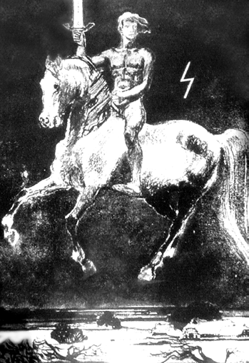
Wotan Kalki, on his horse Sleipnir, with his sword and with his Seig rune. In the Raknarok, the “Dawn of the Gods” or Final Judgment, he returns to judge.

RUDOLF HESS

The most astounding case, since it has occurred here, in our time, in front of our very eyes, is that of Rudolf Hess. The one who flew to England, during the middle of the war, was made prisoner, and was murdered after forty years in the Spandau prison, in Berlin, was not Rudolf Hess. Doctor Hugh Thomas tells us about this in his book The Enigma of Rudolf Hess, published in 1980. He states that when he had to replace a north American doctor in Spandau, and later had to attend Hess’ bronchopneumonia, after analyzing an x-ray of the lungs he discovered with great surprise that a scar from a bullet wound during the First World War was not there. “And a wound in the lung is never erased”, he tells us. More so, this Hess was eating meat (while the real one was a vegetarian) and during the first twenty years he refused to receive the visits of his family, his wife and his son, “fearing that they would not recognize him”. Looking at him straight in the eye doctor Thomas said to him “You are not Rudolf Hess!” Terrified and urinating he tried to flee. When the doctor caught-up with him he stuttered “You are right, but it is too late”.

- 20 -
19

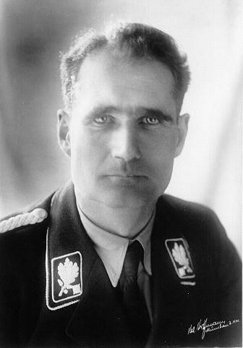
The authentic Rudolf Hess.

Thomas thinks that the true Rudolf Hess was replaced, by orders of Himmler, before initiating the flight; and that the one that flew to Scotland, searching for the Duke of Hamilton to propose peace with England, was a double.

- 21 -
20

Not long ago appeared another book regarding the same subject: Double Standards. The Rudolf Hess Cover-Up, written by Lynn Picket, Clive Prince and Steven Prior. Extending for over four hundred pages, with a great wealth of data and documents, it confirms that the true Rudolf Hess is the one who reaches England, where he is awaited by the Dukes of Kent and of Hamilton. And this is where he was attacked and murdered, dying together with Kent, killed by those who did not want peace. Thus, the “double” was created by the English together with the anti-Hitler Germans. This is the man who later makes those bizarre testimonies during the Nuremberg process, that puzzle his old comrades, among them Goring, von Ribbentrop and Rosenberg.

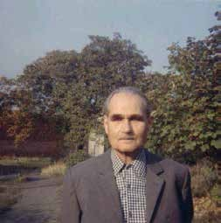
The double.

- 22 -
21

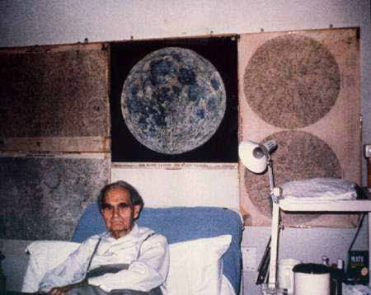
The “double”, in his prison, contemplating a great photograph of the Moon where “his real” Rudolf Hess was.

After so many years in prison, and given the intention of the Russians to liberate the prisoner after the fall of the Berlin wall, the English become worried, because the “double” could be discovered and the whole obscure plot that was woven in the shadow of time and of the years, in the most sinister of the centers of world government, would see the light. With great urgency his murder is planned and carried out, and, as the son of Rudolf Hess reveals in his book “Who Murdered my Father, Rudolf Hess?”, a testicle, the pancreas and other internal organs are extracted from the corpse. It is the international action of the Skull and Bones, and a ritualistic crime fulfilled through the most gruesome deed in the history of mankind.

*****

- 23 -
22

23

However, the true Rudolf Hess was not murdered, not in Germany or in England. He had parted towards the base of Neuschwabenland, in Antarctica³.

And Adolf Hitler knew it, because it was he who had decided it.

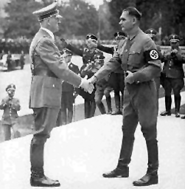
The authentic Adolf Hitler and Rudolf Hess. Both where initiates.

³ See Appendix.

24

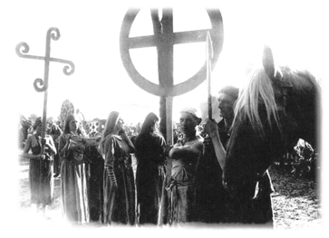

Hitlerist women, wearing the ancient Germanic sacerdotal robes, are heading towards the woods to practice the ancestral cults.

THE ARCHETYPE AND THE AVATARA

The Archetype of the Fuhrer, in the blood or in the “memory of the blood”, is something like a Primordial Idea that lies dormant in the collective unconsciousness of a nation. When it is apprehended and represented by a man it becomes conscious. Generally this man lives a short life, consumed by an internal fire. In compensation, the myth and the legend project him beyond his time.

With the Avatara a somewhat similar situation takes place, although different because it is a Divinity that seeks to express himself, and requires the body of a man for this purpose, generally an initiate who is transformed and transforms himself, being able to gain consciousness of himself, achieving immortality in his body and in his soul, divinizing him as Absolute-Man, as Super-Man (Sonnenmenschen). This is the case of Prince Gautama (when he became Buda resuscitating in Nirvana), Krishna, Muhammad, and Jesus, who transmuted himself into Kristos and resurrected with his body on the third day, whereas Wotan is reborn in the ninth day.
25

And so it was with Adolf Hitler. That is why the true Hitler doesn’t die and, if he does, he too resuscitates on the third or on the ninth day and leaves to Antarctica, towards Neuschwabeland, and, from there to the Moon⁴, to Mars and to Venus⁵ where now he finds himself, at an exact age and forever until his next return in the Raknarok, the “Dawn of the Gods”, when even the Gods die. He will return with Wotan-Kalki on a White Horse, to pass Judgment.

*****

And what happens to the “double”, with “the doubles”? All of them are also incarnations of the Archetype (though not of the Avatara). They had their chance to act as if they were the person they represented, talking and also saying essential things, like Rudolf Hess in the Nuremberg Trial. Surely, in the creation of the Doppelganger, in the perfect duplication achieved in Nazi Germany, an initiation in a yet unknown esoterism was necessary, in a very powerful order connected with the secret Tibet, with Hyperborea and with extraterrestrials. In this way it was possible to “materialize” the astral body, the Lingasarira, and make it ubiquitous; that is to say, not only to duplicate it, but also to multiply it at will. And this was the

⁴ In his room of the Spandau prison, the “double” of Rudolf Hess had in front of him a great photograph of the Moon, where “his” true Hess actually was. On the other hand the United States never again attempted to take over the moon, because when they went –if they ever did– they found it was already occupied.
⁵ See Appendix.

- 27 -
26

mystery that was revealed to me that night in Austria, so long ago⁶.

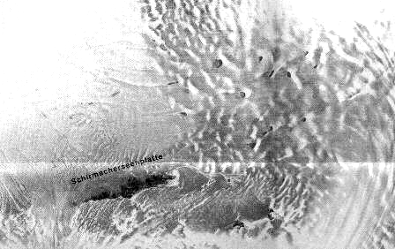
Oasis of warm waters in Antarctica.

⁶ The astral body is the double of the physical body; more exactly the physical body is the double of the “astral”, something like the revealed negative of a photograph (the negative remains and may be revealed as many times as one wishes). The “materialization at will in the astral body” is something that can be achieved only by reactivating the right hemisphere of the brain (tool or “computer” of the mind), which is today atrophied and mostly devoid of activity. And it is precisely there where the centers and registers that are capable of activating the astral double, of resuscitating it and “materializing” it, are found. This was the duplication, the doppelganger achieved by an elite of the SS that was esoterically connected to the most powerful Secret Order of Tibet and Indostan, which still preserves the science of the reactivation of the total brain together with the power of “the resurrection of the flesh”.

- 28 -
27

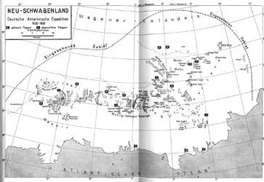
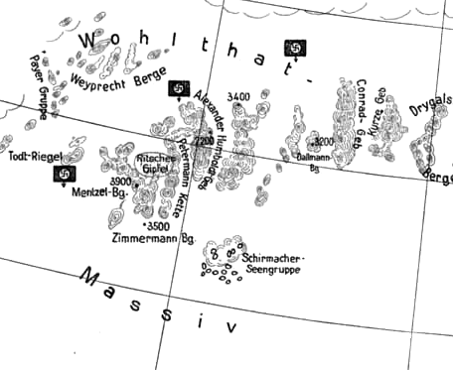

The secret and impregnable Antarctic Base, “a Paradise on Earth for the Fuhrer”.

- 29 -
28

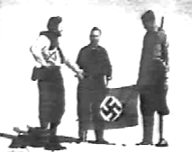
Members of the Hi- tlerist expedition in Antarctica.

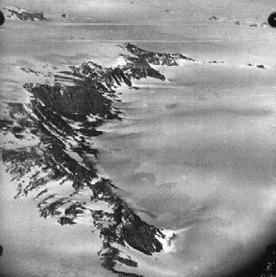
Air view of the Antarctic rifts (30), taken by the 1938-39 German expedition.

- 30 -
29

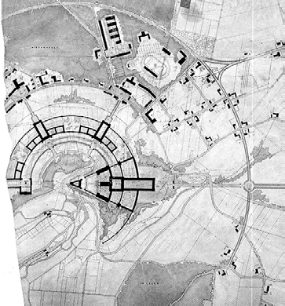

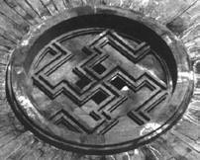
- 31 -
30
The hall of SS initia- tion in the Castle of Wewelsburg.

MAYA

We have lived, and we still live in an illusory world, where nobody knows who is who, nor when we are speaking with a specific person whether we do so with the authentic one, or with someone that does not exist. Today the duplication is plagiarized by a scientific elite at the service of the satanic minority that controls the world (they also count with their Archetype of the “Golem”). This way, everything is illusory; it is Maya, as Hinduism defines reality.

Nevertheless, the Avatara did not lose the war; he won it by losing it. And He said as much: “If I lose this war materially, the demons will destroy the world”.
And the Earth finds itself at the doorsteps of the end. We, who have battled for the Myth and the Legend of
the last Avatara, shall be alert awaiting the coming of
Sleipnir, the White Horse and his Rider, who with his Sword of Fire will throw the demons that have poisoned this Universe into the abyss of Muspelheim.

- 32 -
31

APPENDIX

The Earth is Hollow

About three years ago I received an unexpected visit from a world famous writer. He came from Germany to bring me an extraordinary document: a letter written by a German submarines that declared he was “inside the Earth”, because “Rudolf Hess and Haushofer were right: The Earth is Hollow”, he added.

The letter was handwritten in German and was dated the 20th of April, 1947, which is the anniversary of Adolf Hitler’s birth. We transcribed it, and with it and its translation, another letter in English, from 1990, in which the recipient of the first letter tried to explain what happened.

These documents confirm everything that we have been writing for many years now about Esoteric Hitlerism.

And it is not the first time that these “synchronisms” appear to support us, because like the alchemist says: “If your work is righteous, unknown friends will come in your aid…” and “even if you are alone in your room, your thoughts will be heard a thousand miles away”.

- 33 -
32

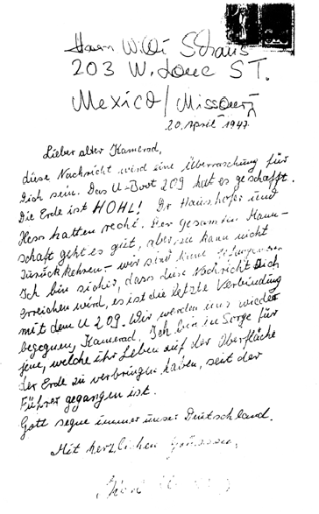

Manuscript letter directed to Hans Willi, dated the 20th of April, 1947.

- 34 -
33

TRANSCRIPTION

20 april, 1947
Lieber alter Kamerad,

Diese nachricht wird eine Überraschung für dich sein. Das U-Boot 209 hat es geschafft. Die Erde ist Hohl! Dr. Haushofer und Hess hatten recht. Der gesamten Mannschaft geht es gut, aber sie kann nicht zurück kehren. Wir sind keine Gefangener. Ich bin sicher dass diese Nachricht dich erreichen wird, es ist die letzte Verbindung mit dem U-209. Wir werden uns wieder begegnen, Kamerad. Ich bin in Sorge für jene welche ihr Leben auf der Oberfläche der Erde zu verbringen haben, seit der Führer gegangen ist.
Gott segne immer unser Deutschland. Mit herzlichen grüssen.

TRANSLATION

Dear Old Comrade,

20th of April, 1947

This letter shall be a surprise to you. The U-Boat 209⁷ has made it. The Earth is HOLLOW! Doctor Haushofer and Hess where right. The entire crew is well, but we cannot return. We are not prisoners. I am sure that this message will reach you; this is the final contact with the U-209. We shall meet again comrade. I am worried about the way life on the surface of the Earth has evolved since the Fuhrer left.
May God bless our Germany forever. Sincerely,

⁷ The U-209 has been missing since the 7th of May of 1943, in the North Atlantic, approximately at 52N, 38W.

- 35 -
34

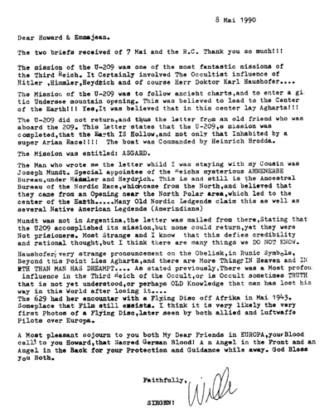

Letter from Hans Willi to Howard and Emmajean, dated the 8th of May, 1990.
35

36

INDEX

Martin Bormann 7
7
Night in Austria 10
11
Hitler 14
15
Rudolf Hess 20
21
The Archetype and the Avatara 26
27
Maya 32
33
Appendix: The Earth Is Hollow 33
35

